SULIT

BAHASA INGGERIS
Kertas 1 - Pemahaman
Tahun 4
Oktober
2019
1$\frac{1}{4}$ jam

PENTAKSIRAN AKHIR TAHUN 2019
TAHUN 4

Nama : ……………………………………………………… Kelas : ………………………

BAHASA INGGERIS
Kertas 1 - Pemahaman

Satu Jam lima belas minit

JANGAN BUKA KERTAS SOALAN SEHINGGA DIBERITAHU

- Kertas soalan ini mengandungi dua bahagian : Bahagian A dan Bahagian B.
- Jawab semua soalan.
- Tiap-tiap soalan dalam Bahagian A diikuti oleh empat pilihan jawapan, iaitu A, B, C dan D. Bagi setiap soalan, pilih satu jawapan sahaja. Hitamkan jawapan kamu pada kertas jawapan objektif yang disediakan.
- Jika kamu hendak menukar jawapan, padamkan tanda yang telah dibuat. Kemudian hitamkan jawapan yang baharu.

Kertas soalan ini mengandungi 13 halaman bercetak

SECTION A
[20 marks]

Questions 1 to 5
Choose the best answer to complete the sentence.
Pilih jawapan yang terbaik untuk melengkapkan ayat berikut.

1. ___________________ is there a big crowd in front of the hall?

A. Where C. When
B. What D. Why

2. Siti ____________ RM 700 for shopping every month.

A. spend C. spent
B. spends D. spending

3. Raziq lock all the doors and windows _________________ leaving his house.

A. until C. before
B. after D. while

4. We must take care of _______________ seas.

A. his C. mine
B. our D. her

5. The police _______________________ the thieves who robbed my house.

A. catch C. give
B. delicate D. caught

Question 6
Choose the most suitable idiom to complete the sentence below.
Pilih simpulan bahasa yang paling sesuai untuk melengkapkan ayat di bawah.

6. The thief was _______________________ by the police.

A. by hook or by crook
B. caught red-handed by the police
C. keep an eye
D. lived from hand to mouth

Questions 7 to 9
Choose the best answer to fill in the blanks in the passage that follows.
Pilih jawapan yang terbaik untuk diisi pada tempat kosong dalam teks yang berikut.

Idham’s neighbourhood residents’ association organised a recycling campaign last Sunday. He has ___________________(7) aluminium cans, jars and used cartons from ______________________(8) relatives and friends. He _______________(9) the recyclable items to the campaign and received canvas bag and notebook made from recycled paper.

7. A. collected B. collecting C. collect D. collects

8. A. their B. his C. her D. our

9. A. take B. taking C. took D. takes

Question 10
Choose the word that has the same meaning as the underlined word.
Pilih perkataan yang sama maksud dengan perkataan yang bergaris.

10. The Sumatran rhinoceros is the only Asian rhino with two horns. It is a species
that is critically endangered.

A. protected C. good
B. authentic D. at risk

Question 11
Choose the sentence with the correct punctuation.
Pilih ayat yang mempunyai tanda baca yang betul.

11. A. I enjoy eating cakes, fried rice, burgers and pizzas.
B. I enjoy eating Cakes, Fried rice, Burgers and Pizzas.
C. I enjoy eating, cakes, fried rice, burgers and pizzas.
D. I enjoy eating cakes fried rice burgers and pizzas.

Questions 12 to 15
Look at the picture and choose the best answer.
Lihat gambar dan pilih jawapan yang terbaik.

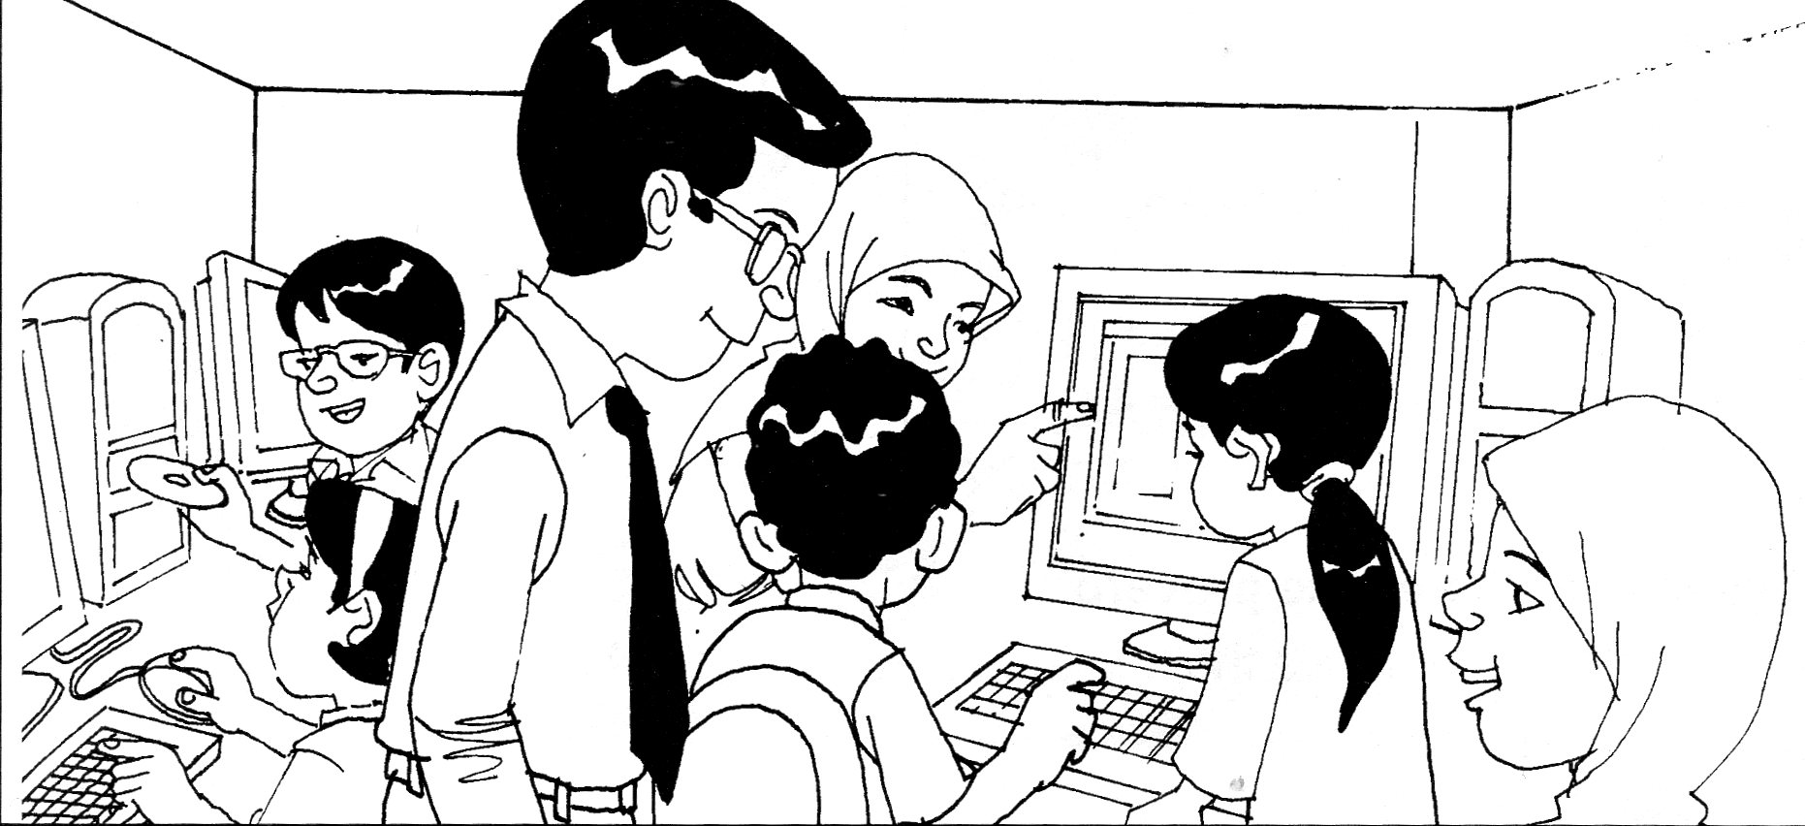

The pupils are in the computer room. All the pupils seemed to be ________________(12). Sufi is teaching Ain on ________________(13) to start operating a computer. Meanwhile, Puan Ina is showing Sharif on how to _________________(14) a blog. Mr. Zamri the headmaster is also ___________________(15) attentively.

12. A. busy B. quiet C. sleepy D. tired

13. A. where B. why C. where D. how

14. A. create B. creates C. created D. creating

15. A. listens B. listen C. listened D. listening

Questions 16 to 20
Read the information below and answer the questions that follow.
Baca maklumat di bawah dan jawab soalan-soalan yang berikutnya.

Moon facts | Sun facts
- The moon is the Earth’s only natural satellite.  - The moon was formed 4.6 billion years ago.  - Diameter : 3 475 km  - Average distance from Earth : 384 400 km  - Surface temperature : -233 C to 123 C  - The rise and fall on the tides on Earth is caused by the moon.  - A person on the moon would weigh about 1/6 of his weigh on Earth.  - The moon has no atmosphere. Therefore, the sky remains black and no sound can be heard. | - The sun is the star at the center of the solar system.  - Age : 4.6 billion years  - Diameter : 1 393 684 km  - Average distance from Earth : 149 598 262 km  - Surface temperature: 5 500 C  - The sun has a very strong magnetic field which is released during magnetic storms.  - One million Earth could fit inside the sun.  - The sun contains three quarter hydrogen and the rest is helium.

16. What is the Earth’s natural satellite?

A. The Sun C. The Moon
B. Mercury D. Jupiter

17. Why no sound can be heard on the moon?

A. The rise and fall of tides effect C. Strong magnetic field
B. It has no atmosphere D. It is smaller than the sun

18. How far a spaceship will travel to go to the moon?

A. 3 475 km C. 1 393 684 km
B. 384 400 km D. 4.6 billion years

19. A man who weighs 60 kg on Earth will only weigh __________ kg on the moon.

A. 6 kg
B. 10 kg
C. 30 kg
D. His weight remains the same

20. Which statement below is TRUE.

A. 1/4 of the mass of the mass of the sun is helium.
B. The rise and the fall of the tides on Earth is caused by magnetic storms.
C. The sun is bigger than the moon.
D. The moon is hotter than the sun.

SECTION B
[30 marks]

Question 21
Write a suitable response for each picture in the space provided.
Tulis jawapan yang sesuai bagi setiap gambar di ruang yang disediakan.

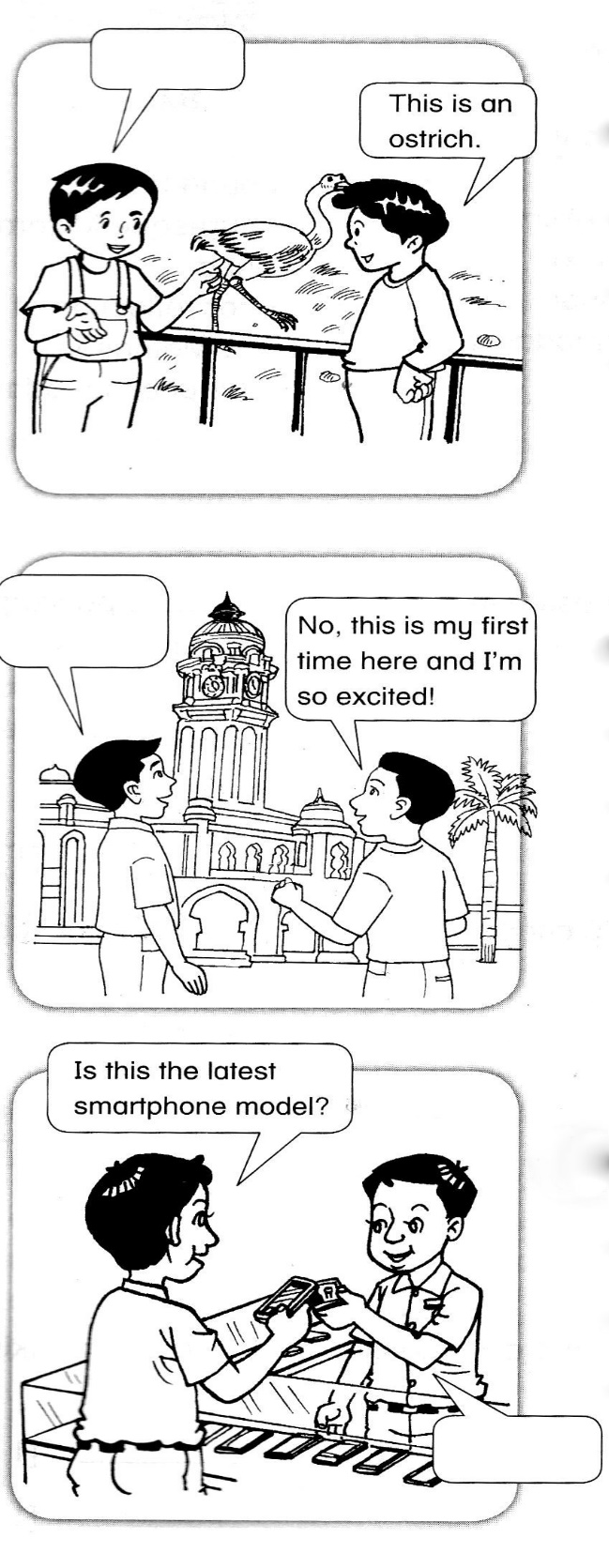

Answer:

____________________________________

___________________________________

__________________________________
a)

[2 marks]

Answer:

____________________________________

___________________________________

__________________________________
b)

[2 marks]

Answer:

____________________________________

___________________________________

__________________________________
c)

[2 marks]

Question 22
Study the map and answer the questions that follow.
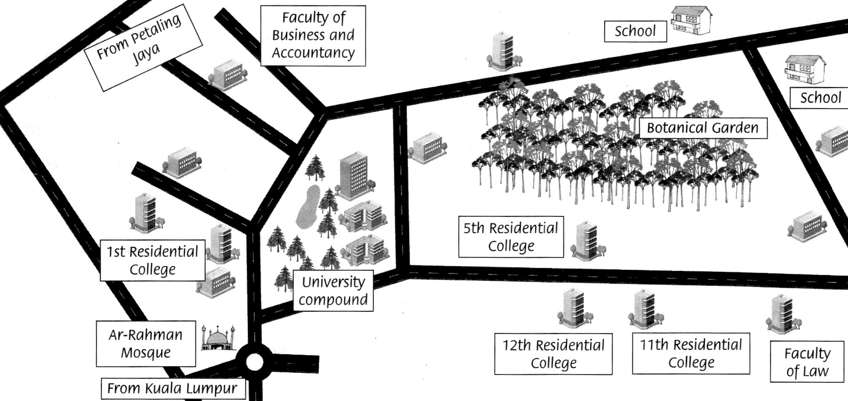
Teliti peta di bawah dan jawab soalan-soalan yang berikutnya.

Tick ( √ ) the correct answer.
Tandakan ( √ )pada jawapan yang betul.

a) The faculty of law is near the…

- Petaling Jaya ( )
- University Compound ( )
- 11th Residential College ( )
[1 mark]
b) How many schools are there in the area?

- one ( )
- two ( )
- three ( )
[1 mark]
Write your answer in the space provided.
Tuliskan jawapan anda di ruangan yang disediakan.

c) Razak and Din are staying in Residential College 5. Where do you think they
will go for jogging and strolling?

___________________________________________________________________________

________________________________________________________________________
[2 marks]

d) How do you go to Ar-Rahman Mosque if you’re from Petaling?

___________________________________________________________________________

___________________________________________________________________________
[2 marks]

e) There are a lot of trees and plants in the compound of the university. Why do you think the trees and plants are for?

___________________________________________________________________________

___________________________________________________________________________
[2 marks]

Question 23
Study the story below and answer the questions that follow.
Teliti cerita di bawah dan jawab soalan-soalan yang berikutnya.

Eugene is a Chinese boy who lives in China. His father is a farmer. They are living in a village where there are no modern facilities. They are poor but happy. Their father always teaches Eugene and his brother Kaw Siang about how important are vegetable for health. Every day, their father goes to the farm early in the morning. He plants various types of vegetables.
Eugene’s mother will cook for them and take good care of them. She also will walk them to the school. Since small, they both grew up eating the green vegetables and the fresh fruit from their father’s farm. Eugene also learns to plant vegetables. Meanwhile, they both will always help their father during the school holidays.
They have never eaten fast foods or been to the restaurant. They are always thankful to their father for providing them with food daily from their own farm. Eugene and his brother promised to their father that once they grow up, they will plant their own vegetables.
Today, both Eugene and Kaw Siang are famous organic vegetable farm owners in Beijing. Their vegetables are exported to various countries around the world.

Tick ( √ ) the correct answer.
Tandakan ( √ )pada jawapan yang betul.

a) The story is about…

- vegetables and their benefit ( )
- Eugene and his family ( )
- two kind happy Chinese boys ( )

[1 mark]
b) Eugene’s family always thankful to…

- their father ( )
- the farm ( )
- the villagers ( )
[1 mark]

c) Match the phrases in List A to the suitable phrase in List B. One has been done for you.
List A
Eugene is a
They are poor
Their father plants
They have never
List B
but happy.
eaten fast foods.
various types of vegetables.
Chinese boy who lives in China.

[2 marks]

Write your answer in the space provided.
Tuliskan jawapan anda di ruangan yang disediakan.

d) Give two words to describe Eugene’s father

- ________________________________________________________________________

- ________________________________________________________________________
[2 marks]

e) In your opinion, why do you think vegetable are good for us?

___________________________________________________________________________

___________________________________________________________________________
[2 marks]

Question 24 and 25
Study the expense bill and read the dialogue below then answer the questions that follow.
Teliti bil perbelanjaan dan baca dialog di bawah kemudian jawab soalan-soalan yang berikutnya.

Encik Hanif earns RM 2800 a month as a teacher in a school.
He gives his wife RM 1800.
She spends the money on the following.

Grocery items | RM 500
Utility bills | RM 250
House rental | RM 600
Pocket money for Raisya and Rahim | RM 100
New straits times | RM 45
Entertainment | RM 200
Savings | RM 105

Nuh : Amin, do you know how much money Encik Hanif gives his wife in a month?
Amin : Yes, I do. He earns about RM 2 800.00 a month and gives his wife RM 1 800.00.
Nuh : What does his wife spend most of the money on?
Amin : She spends most of the money on house rental. Spends about RM 600.00.
Nuh : How much does she spend for paying the utility bills, Amin?
Amin : Well, she spends about RM 250.00 to pay for the utility bills.
Nuh : Does she save any money in the month, Amin?
Amin : Yes, she manages to save about RM 105.00 every month.
Nuh : How much money does she spend on pocket money for Raisya and Rahim?
Amin : She spends about RM 100 on pocket money for Raisya and Rahim.

Tick ( √ ) the correct answer.
Tandakan ( √ )pada jawapan yang betul.

24. a) How much does Encik Hanif’s wife spend for newspaper and
entertainment?

- RM 245.00 ( )
- RM 145.00 ( )
- RM 305.00 ( )
[1 mark]

b) His wife spends the least amount of money on…

- Entertainment ( )
- Utility bills ( )
- Newspaper ( )
[1 mark]

25. a)
“for paying the utility bills”

Why do you think utility bills are?

____________________________________________________________________

___________________________________________________________________
[2 marks]

b) How much does Encik Hanif keep for himself for his own expenses?

____________________________________________________________________

___________________________________________________________________
[2 marks]

c) Do you think Encik Hanif’s wife spends her money wisely? Give
reasons to support your answer.

____________________________________________________________________

___________________________________________________________________
[2 marks]

End of question

ANSWER SCHEME

- D
- B
- C
- B
- D
- B
- A
- B
- C
- D
- A
- A
- D
- A
- A
- C
- B
- B
- A
- C

Question 21

- What animal is this?
- Do you come here often?
- Yes, it is.

Question 22

- 11th Residential Collage
- two
- Botanical Garden. It is the nearest garden for the to jog and keep fit.
- From Petaling Jaya, go straight and then turn left, go down the road and you will see Ar-Rahman Mosque on your left.
- The trees provide fresh air and oxygen for surrounding places.

Question 23

- Eugenie and his family
- Their father

List A
Eugene is a
They are poor
Their father plants
They have never
List B
but happy.
eaten fast foods
various types of vegetables
Chinese boy who lives in China

- I. diligent II. hardworking

- Vegetables give us good vitamins and minerals.

Question 24

- RM 245.00
- newspaper

Question 25

- utility bills are like water, electricity, telephone and Astro bills.
- Encik Hanif puts aside RM 1000 from his salary for his own expenses.
- Yes, I think Encik Hanif’s wife is a wise spender because she able to save RM 105.00 every month.

ISI KANDUNGAN

No. | Topic | Aspect
1 | Our Community | Grammar
2 | Spending Wisely
3 | Be Safe
4 | Care for the Sea
5 | The Prince and The Thief
6 | Be Safe | Idiom
7 | Good Values | Grammar
8 | Good Values
9 | Good Values
10 | Blogging | Vocabulary
11 | Harmony in the Jungle | Punctuation
12 | Blogging | Grammar
13 | Blogging
14 | Blogging
15 | Blogging
16 | Our Solar System | Comprehension
17
18
19
20
21 | Going Places | Response
22 | Going Places | -Comprehension  -Items  -Grammar
23 | Good Values
24 | Spending Wisely
25 | Spending Wisely

