SULIT

BAHASA INGGERIS
Kertas 1 - Pemahaman
Tahun 3
Oktober
2018
1$\frac{1}{4}$ jam

PENTAKSIRAN AKHIR TAHUN 2018
TAHUN 3

Nama : ……………………………………………………… Kelas : ………………………

BAHASA INGGERIS
Kertas 1 - Pemahaman

Satu Jam lima belas minit

JANGAN BUKA KERTAS SOALAN SEHINGGA DIBERITAHU

- Kertas soalan ini mengandungi dua bahagian : Bahagian A dan Bahagian B.
- Jawab semua soalan.
- Tiap-tiap soalan dalam Bahagian A diikuti oleh empat pilihan jawapan, iaitu A, B, C dan D. Bagi setiap soalan, pilih satu jawapan sahaja. Hitamkan jawapan kamu pada kertas jawapan objektif yang disediakan.
- Jika kamu hendak menukar jawapan, padamkan tanda yang telah dibuat. Kemudian hitamkan jawapan yang baharu.

Kertas soalan ini mengandungi 11 halaman bercetak

SECTION A
[20 marks]

Questions 1 to 5
Choose the best answer to complete the sentence.
Pilih jawapan yang terbaik untuk melengkapkan ayat berikut.

1. Raflizal bought ______________ new computer yesterday.

A. a C. the
B. an D. it

2. Aiman did not win the competition _____________ he did not try hard.

A. and C. but
B. because D. or

3. Arisah and Tajul like to play chess. ________________ play during their free time.

A. My C. We
B. They D. She

4. Jasri is sitting _____________ Nadiah and Habibah.

A. under C. between
B. beside D. above

5. Kiki’s father repair cars. He is a/an ______________________.

A. mechanic C. teacher
B. tailor D. engineer

Question 6
Choose the most suitable proverb.
Pilih peribahasa yang paling sesuai.

6. Even Zharif has a stern face, he is kind hearted. As the saying goes_____________________________________.

A. don’t judge a book by its cover
B. the blind leading the blind
C. empty cans make the most noise
D. between the devil and the deep blue sea

Questions 7 to 9
Choose the best answer to fill in the blanks in the passage that follows.
Pilih jawapan yang terbaik untuk diisi pada tempat kosong dalam teks yang berikut.

Last Saturday, SK Kijang Serai held a ‘gotong royong’. Amirul and Adli helped their teachers to _______________ the teacher’s garage. The girls from 6 Bijak ____________ the dried leaves in the garden near the garage. They collected all the rubbish and put it _____________ the recycle bin.

7. A. cleaned B. cleaning C. clean D. cleans

8. A. swept B. sweeping C. sweeps D. sweep

9. A. in B. out C. into D. under

Question 10
Choose the word that has the opposite meaning as the underlined word.
Pilih perkataan yang bertentangan dengan perkataan yang bergaris.

10. Sharvess bought a ring which was expensive for his mother.

A. cheap C. modern
B. ancient D. luxurious

Question 11
Choose the sentence with the correct punctuation.
Pilih ayat yang mempunyai tanda baca yang betul.

11. A. “Wow!” your painting is beautiful. Said Tajudin to Faiz.
B. “Wow!” your painting is beautiful. said Tajudin to Faiz
C. “Wow! Your painting is beautiful,” said Tajudin to Faiz.
D. “Wow! your painting is beautiful.” Said Tajudin to Faiz

Questions 12 to 15
Look at the picture and choose the best answer.
Lihat gambar dan pilih jawapan yang terbaik.

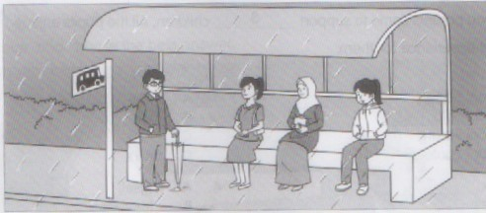

It is raining. Sarimah and two ladies (12)______________ at the bus stop. They are waiting patiently (13)___________ the bus. Sarimah is holding a bag. The man is wearing a pair of spectacles and holding (14)____________ umbrella. The other lady is wearing a jacket. They are (15)_____________ side by side. The bus will arrive soon.

12. A. is B. are C. was D. were

13. A. by B. for C. will D. in

14. A. a B. an C. the D. for

15. A. standing B. sleeping C. sitting D. sleeping

Questions 16 to 20
Read the passage below and answer the questions that follow.
Baca petikan di bawah dan jawab soalan-soalan yang berikutnya.
PULAU PANGKOR AUGUST 2018

Hurry Up ! Don’t miss the deal!
Call Miss Amira at 013-563489 for booking
promotion end September 2018
p

1 person
RM 200
3 days 2 nights

ACTIVITIES :
- VISIT A FISHING VILLAGE
- SNORKELLING
- BARBECUE
- EATING TRADITIONAL FOOD

16. The advertisement is about

A. Pulau Pangkor festival C. Traditional food
B. Visiting Pulau Pangkor D. Fishing competition

17. How would you book the package above?

A. contact Miss Amira C. go to Pulau Pangkor
B. contact fishing village D. go to tourism agency

18. Suriati wants to go with her mother. How much would she spend?

A. RM 200 C. RM 400
B. RM 600 D. Less than RM 200

19. Promotion available until

A. August 2018 C. July 2018
B. September 2018 D. The whole year

20. Which statement is TRUE?

A. the package is for 4 days
B. you have to pay for snorkelling
C. promotion is on August 2018 only
D. the package includes scuba diving

SECTION B
[30 marks]

Question 21
Write a suitable response for each picture in the space provided.
Tulis jawapan yang sesuai bagi setiap gambar di ruang yang disediakan.

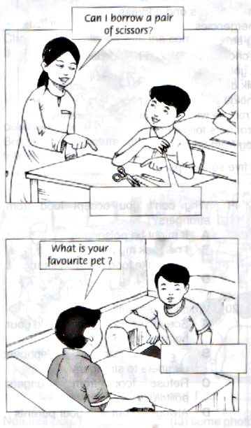
Answer:

__________________________________

__________________________________

__________________________________
a)

[2 marks]

b)
Answer:

_________________________________

_________________________________

__________________________________

[2 marks]

wwwwwwwwwwwwwwwwwwwwwwwwwwwwwwwwwwwwwwwwwwwww
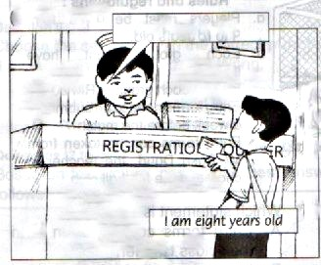
Answer:

___________________________________

___________________________________

__________________________________
c)

[2 marks]
Question 22
Read the story below and answer the questions that follow.
Baca cerita di bawah dan jawab soalan-soalan yang berikutnya.
Alif is a hardworking boy. He is from a poor family. He lives in an old hut near the river with his mother and two younger sisters. Alif has two special pets. His two pets are chickens. He calls them Cici and Didi.
Cici and Didi live in a coop behind Alif’s house. They eat special food that Alif bought at the pet shop. Alif work hard to buy food for his chickens. When the hens are outside, they love to eat bugs they catch in the yard. Cici and Didi even like to eat worms they pull out of the ground.
Cici and Didi are special, they lay eggs. The eggs then will hatch, and chicks will come out of the egg shells. Alif now has a lot of chicken. He helped his family by selling eggs and chickens to the villagers.

Tick ( √ ) the correct answer.
Tandakan ( √ )pada jawapan yang betul.

a) Alif’s hens live in a…

- coop ( )
- house ( )
- forest ( )
[1 mark]
b) Alif’s hens eat…

- pet food ( )
- biscuit ( )
- grass ( )
[1 mark]

Write your answer in the space provided.
Tuliskan jawapan anda di ruangan yang disediakan.

c) What are other foods that Alif’s chickens eat?

___________________________________________________________________________

________________________________________________________________________
[2 marks]
d) Why do you think Alif work hard to buy food for the chickens?

___________________________________________________________________________

___________________________________________________________________________
[2 marks]

e) What can you learn from the story?

___________________________________________________________________________

___________________________________________________________________________
[2 marks]

Question 23
Study the notice below and answer the questions that follow.
Teliti notis di bawah dan jawab soalan-soalan yang berikutnya.

Zinzin Electric Store
Laptop | Computer | Tablet
- Portable  - 6 hours usage on battery  - Battery: Yes  - Price : RM 1000 (10% discount)  - Weight : Light  - Internet connection: Yes | - Not portable  - 24 hours usage on power supply  - Battery: No  - Price : RM 600 (20% discount)  - Weight : Heavy  - Internet connection: Yes | - Portable  - 8 hours usage on battery  - Battery: Yes  - Price : RM 2000 (15% discount)  - Weight : Light  - Internet connection: Yes

Tick ( √ ) the correct answer.
Tandakan ( √ )pada jawapan yang betul.

a) Which of the following items have the lowest price…

- Laptop ( )
- Computer ( )
- Tablet ( )
[1 mark]
b) Which of the following items have the highest discount …

- Laptop ( )
- Computer ( )
- Tablet ( )
[1 mark]

c) Match the phrases in List A to the suitable phrase in List B. One has been done for you.
List A
No battery
6 hours of usage
RM 2000
Internet connection
List B
Laptop
tablet
All gadgets
Computer

[2 marks]

Write your answer in the space provided.
Tuliskan jawapan anda di ruangan yang disediakan.

d) List two things you can do with a computer.

- ________________________________________________________________________

- ________________________________________________________________________
[2 marks]

e) Ali is a traveller. Which gadget do you think suitable for him? Why?

___________________________________________________________________________

___________________________________________________________________________
[2 marks]

Question 24 and 25
Study the advertisement and read the dialogue below then answer the questions that follow.
Teliti iklan dan baca dialog di bawah kemudian jawab soalan-soalan yang berikutnya.

Pink Lychee Pudding
(for 25 cups)
Ingredients:
1 packet of white agar – agar
1 can of white condensed milk
5 cans of water
Garnish: Canned lychee
Instructions:
- Drain the lychees from the can. Then, crush the lychees in a mixer.
- Mix all the ingredients in a pot and then boil the mixture.
- Pour the mixture into small individual cups.
- Pop in 1 tablespoon of the crushed lychees into the cups.
- Refrigerate for 4 to 5 hours. Serve cold.

Anis : Hello mom, guess what I prepared today?
Mom : What is it Anis? Is it the pink lychee pudding that you asked for the
recipe last night?
Anis : Yes, you are right mom! I made it exactly like how you taught me. It was
quite easy.
Mom : Did you use the mixer by yourself?
Anis : No, dad help me to do that.
Mom : What about your little sister?
Anis : She was so busy with her dolls. But now she is asking for more! She has
already finished two cups!
Mom : Save some for me too. I would love to taste your cooking.
Anis : Sure mom! You can eat it during dinner after you come back from
school.

Tick ( √ ) the correct answer.
Tandakan ( √ )pada jawapan yang betul.

24. a) Which of the following is not the ingredient…

- Agar - agar ( )
- Lychee ( )
- Sugar ( )
[1 mark]

b) How long Anis need to refrigerate the pudding?

- 2 – 3 hours ( )
- 4 – 5 hours ( )
- 1 day ( )
[1 mark]

25. a)
“It was quite easy”

Why do you think Anis said that?

____________________________________________________________________

___________________________________________________________________
[2 marks]

b) Do you think Anis’s father helped her to use the mixer? Why?

____________________________________________________________________

___________________________________________________________________
[2 marks]

c) Do you think pudding is a healthy food? Give reasons to support your answer.

____________________________________________________________________

___________________________________________________________________
[2 marks]

End of question

ANSWER SCHEME

- A
- B
- B
- C
- A
- A
- C
- A
- C
- A
- C
- B
- B
- B
- C
- B
- A
- C
- B
- C

Question 21

- Yes, here you go
- My favourite pet is cat
- How old are you?

Question 22

- coop
- pet food
- They eat bugs and worms
- Alif work hard to buy food so his pet will be healthy
- Work hard to improve life.

Question 23

- computer
- computer

List A
No battery
6 hours of usage
RM 2000
Internet connection
List B
Laptop
tablet
All gadgets
Computer

- I. Play games II. Chat online

- Tablet because it is portable and light

Question 24

- sugar
- 4-5 hours

Question 25

- I think she says that because it does not take a lot of effort.
- Yes, it is dangerous for her to operate electrical devices.
- No, because pudding is sweet /Yes, because it contains fruit.

