SULIT

BAHASA INGGERIS
Kertas 1 - Pemahaman
Tahun 1
Oktober
2018
1$\frac{1}{4}$ jam

PENTAKSIRAN AKHIR TAHUN 2018
TAHUN 1

Nama : ……………………………………………………… Kelas : ………………………

BAHASA INGGERIS
Kertas 1 - Pemahaman

Satu Jam lima belas minit

JANGAN BUKA KERTAS SOALAN SEHINGGA DIBERITAHU

- Kertas soalan ini mengandungi dua bahagian : Bahagian A dan Bahagian B.
- Jawab semua soalan.
- Tiap-tiap soalan dalam Bahagian A diikuti oleh empat pilihan jawapan, iaitu A, B, C dan D. Bagi setiap soalan, pilih satu jawapan sahaja. Hitamkan jawapan kamu pada kertas jawapan objektif yang disediakan.
- Jika kamu hendak menukar jawapan, padamkan tanda yang telah dibuat. Kemudian hitamkan jawapan yang baharu.

Kertas soalan ini mengandungi 11 halaman bercetak

SECTION A
[20 marks]

Questions 1 to 5
Choose the best answer to complete the sentence.
Pilih jawapan yang terbaik untuk melengkapkan ayat berikut.

1. Arif has two ____________.

A. pencils C. pencil
B. pensil D. penscil

2. There are three ____________ in the sky.

A. cat C. bird
B. cats D. birds

3. Ali has a pen. ______________ pen is blue.

A. his C. her
B. he D. she

4. Siti is eating _____________ ice-cream.

A. an C. a
B. its D. two

5. The books _____________ on the table.

A. are C. is
B. of D. but

Questions 6 to 8
Choose the best answer to fill in the blanks in the passage that follows.
Pilih jawapan yang terbaik untuk diisi pada tempat kosong dalam teks yang berikut.

Amir has got two pineapples ______ two mushrooms. He buys the pineapples and mushrooms _______________ the market. One pineapple is seven ringgit. One mushroom ______________ one ringgit. Amin spends eight ringgit at the market.
.

6. A. an B. and C. with D. also

7. A. on B. at C. in D. under

8. A. is B. are C. on D. the
Question 9
Choose the word that has the opposite meaning as the underlined word.
Pilih perkataan yang berlawanan maksud dengan perkataan yang bergaris.

9. The doll is ugly.

A. slow C. beautiful
B. big D. long

Question 10
Choose the sentence with the correct punctuation.
Pilih ayat yang mempunyai tanda baca yang betul.

10. A. tigers are orange white and black
B. Tigers are Orange, White and Black.
C. Tigers are orange, white and black.
D. Tigers are orange, white and black

Question 11
Choose the answer with the correct spelling.
Pilih jawapan yang mempunyai ejaan yang betul.

11.

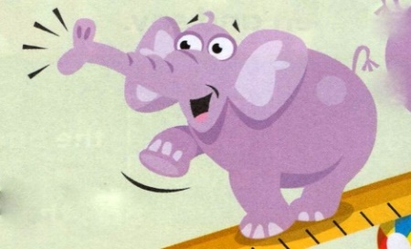

A. elephant C. eliphant
B. elphant D. eleaphan

Questions 12 to 15
Based on the picture, choose the best answer to fill in the blanks in the passage that follows.
Berdasarkan gambar, pilih jawapan yang terbaik untuk diisi pada tempat-tempat kosong dalam teks yang berikutnya.

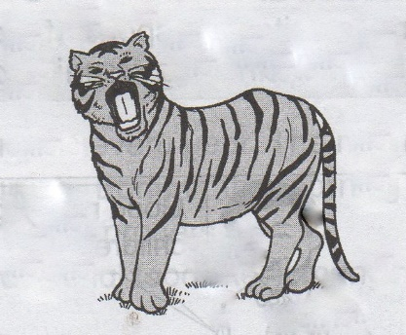

This is (12)___________ tiger. It has stripes (13)_________ its body. It has sharp claws. Tigers (14)___________ carnivores. They eat meat. Tigers come out at night in the jungle. We can see tigers (15)___________ the zoo.

12. A. a B. an C. of D. two

13. A. at B. in C. on D. near

14. A. are B. is C. am D. was

15. A. in B. on C. near D. beside

Questions 16 to 20
Read the passage and answer the questions that follow.
Baca petikan dan jawab soalan-soalan yang berikutnya.

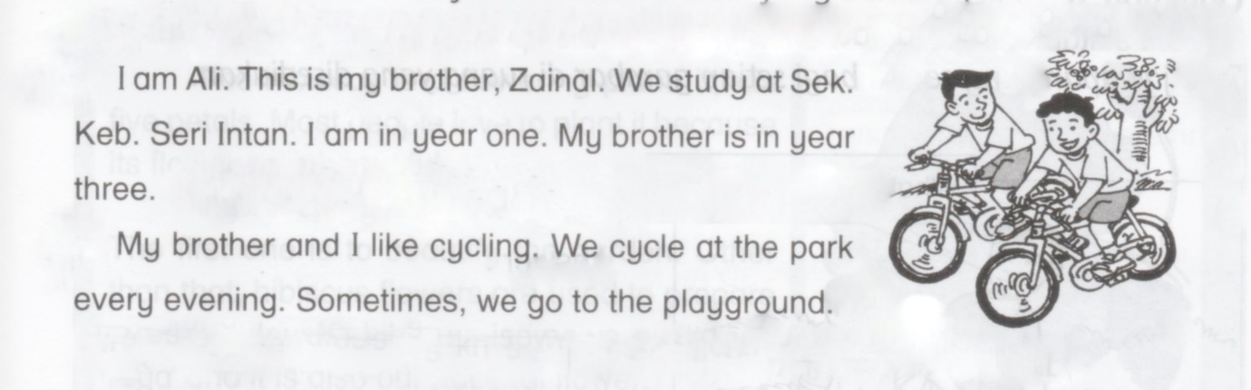

16. Ali and Zainal cycle at the park every ___________.
A. afternoon C. evening
B. morning D. night

17. Ali is in year_____________.
A. three C. two
B. four D. one

18. Zainal is Ali’s _________________.
A. sister C. father
B. mother D. brother

19. Ali and Zainal cycle at the________________.
A. park C. school
B. library D. garden

20. Ali is studying at________________.
A. Sek. Keb Seri Intan C. Sek. Keb. Jati
B. Sek. Keb. Kg Aman D. Sek. Keb Putra

SECTION B
[30 marks]

Question 21
Read the information in the menu and answer the questions that follow.
Baca maklumat di dalam menu dan jawab soalan-soalan berikutnya.

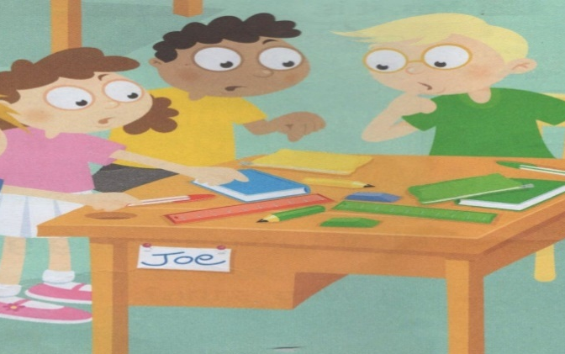
Siti : Hi. Good Morning Joe, How are you?
Joe : Hi. Good Morning Siti, I’m fine. Here’s a pencil. Is it yours?
Siti : No, it isn’t.
Joe : Here’s a ruler. Is it yours?
Siti : Yes, it is. Can you pass it to me, please?
Joe : Here you are. Can you pass the book, please?
Siti : Here you are.
Joe : Thanks, Siti.
Siti : You are welcome, Joe.

Tick (√) the correct answer.
Tandakan ( √ )pada jawapan yang betul.

a) The conversation happens in the

- morning ( )
- night ( )
[1 mark]

b) Siti wears a skirt and a shirt, Siti is a

- boy ( )
- girl ( )
[1 mark]

c) Match the phrase in List A to the suitable response in List B. One has been done for you.

Welcome
Good Morning
I’m fine
List B
Thanks
How are you
Good Morning
List A

[2 marks]

Write your answer in the space provided.
Tulis jawapan kamu di ruang yang disediakan.

d) Is the pencil belong to Siti?

__________________________________________________________________________
[2 mark]

e) How does Joe politely ask for the book from Siti?

__________________________________________________________________________
[2 mark]

Question 22
Read the story below and answer the questions that follow.
Baca cerita di bawah dan jawab soalan-soalan yang berikutnya.

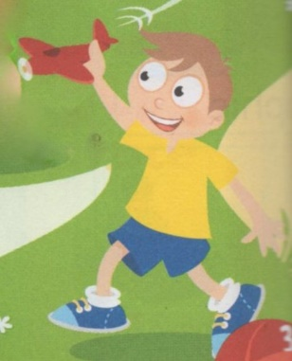
What’s his name? | His name’s Umar
How old is he? | He’s seven
What’s his favourite toy? | His favourite toy’s his red plane
What’s his favourite colour? | His favourite colour is yellow

Tick (√) the correct answer.
Tandakan ( √ )pada jawapan yang betul.

a) The boy’s name is

- Umar ( )
- His ( ) [1 mark]

b) The colour of the plane is

- Red ( )
- Blue ( )
[1 mark]

Write your answer in the space provided.
Tulis jawapan kamu di ruang yang disediakan.

c) How old is Umar?

Umar’s _______________ .
[2 marks]

d) Umar’s favourite toy is _____________________. [2 marks]

e) What is Umar favourite colour?

Umar favourite colour is ____________________________. [2 marks]
Question 23
Look at the picture below and answer the questions that follow.
Lihat gambar di bawah dan jawab soalan-soalan yang berikutnya

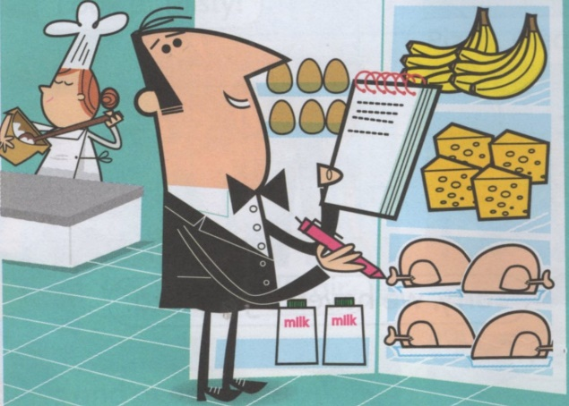
Tick (√) the correct spelling.
Tandakan ( √ )pada ejaan yang betul.

- 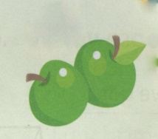

- Appel ( )
- Apple ( )
[1 mark]

- 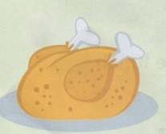

- Chicken ( )
- Chikken ( )
[1 mark]

Write your answer in the space provided.
Tulis jawapan kamu di ruang yang disediakan.

c) How many cheeses are in the picture?

There are ______________ cheeses in the picture.
[2 marks]

d) How many chickens and eggs are in the picture?

_________________________________________________________________ [2 marks]

Questions 24 and 25
Read chant. Then, answer the questions that follow.
Baca maklumat yang diberi. Kemudian, jawab soalan-soalan yang berikutnya.

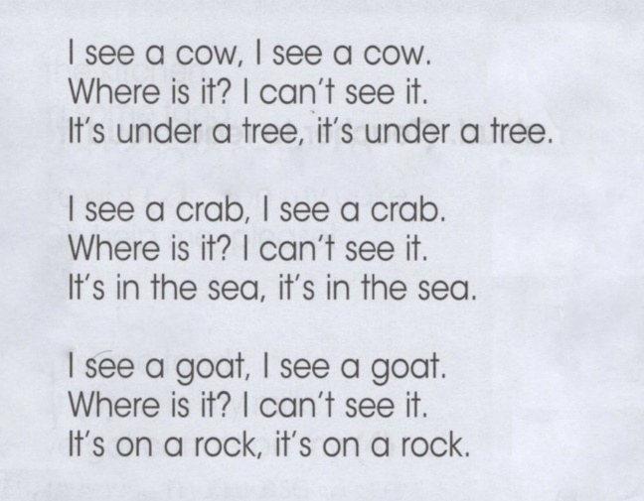

Question 24
Tick (√) the correct answer.
Tandakan ( √ )pada jawapan yang betul.

a) How many crabs is in the chant?

- One ( )
- Two ( )
[1 mark]
b) How many cows is in the chant?

- Two ( )
- Three ( )
[1 mark]

Question 25
Write your answer in the space provided.
Tulis jawapan kamu di ruang yang disediakan.

a) List two animals from the chant.

i. ___________________

ii. ___________________
[2 marks]

b) Where is the crab?

___________________________________________________________________________

[2 marks]

c) What is under the tree?

__________________________________________________________________________

[2 marks]

End of question

ANSWER SCHEME

Section A
- A
- D
- A
- A
- A
- B
- B
- A
- C
- C
- A
- A
- C
- A
- A
- C
- D
- D
- C
- A

Section B

Question 21

a) morning
b) girl

c)
List A
Good Morning
How are you?
Thanks
List B
I’m fine
Good Morning
Welcome

d) No, it isn’t.

e) Can you pass the book, please?

Question 22

a) Umar
b) red
c) seven
d) red plane
e) yellow

Question 23

a) Apple
b) Chicken
c) four
d) There are ten chickens and eggs in the picture.

Question 24

a) two
b) two

Question 25

a) i. cow
ii. crab / goat

b) It’s in the sea.
c) It’s a cow.

