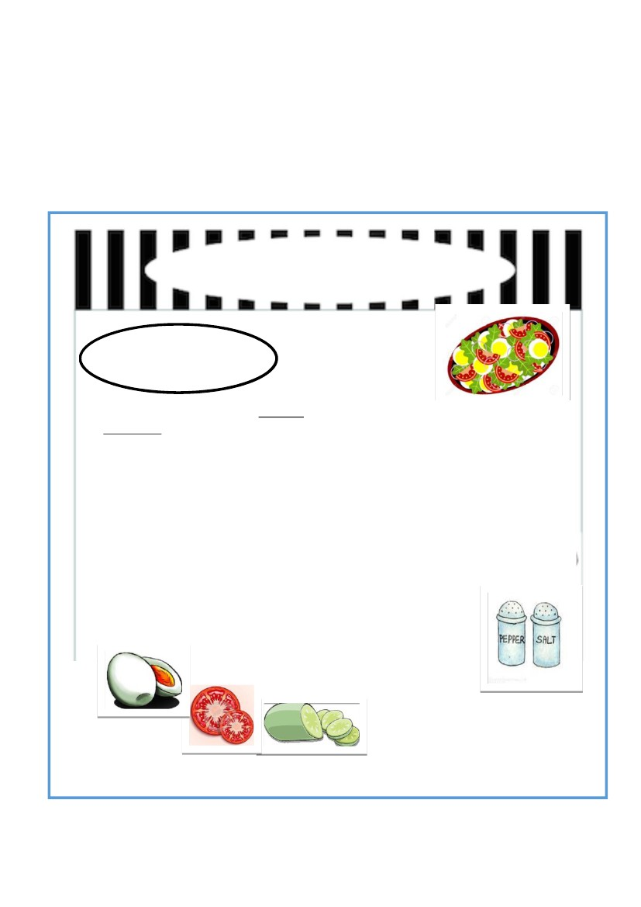
Section A
(10 marks)
Read the recipe carefully. Use the information to complete the text.
Baca resepi di bawah dengan teliti. Gunakan maklumat yang diberi untuk lengkapkan teks di
bawah.

Egg Salad
A delicious and healthy
meal
Methods
Ingredients
1 cucumber
1 hard-boiled egg
1 tomato
1 red chilli
1 lime
1/2 teaspoon salt
1 teaspoon pepper
1. Wash all the vegetables.
2. Slice the cucumber, tomato, and
the chilli.
3. Shell the egg and slice it.
4. Put all the ingredients in a bowl.
5. Cut and squeeze the lime juice over the
vegetables.
6. Add the salt and pepper.
7. Mix the ingredients well.
8. Serve on a plate.
1

Based on the recipe complete the text below with the correct information.
Berdasarkan resepi di atas, lengkapkan teks dengan maklumat yang betul.
I like cooking for my family. My favourite recipe is _________________________. It
(1)
is __________________________ and healthy meal. In order to make this salad, we have to
(2)
prepare the main ingredients first. We have to wash all the vegetables and
______________________________ the egg before we slice them. Then, mix all the
(3)
ingredients in a bowl before we add the __________________________________. Finally,
(4)
we can serve the salad on ___________________________ and it is ready to be eaten.
(5)
(10 marks)
2

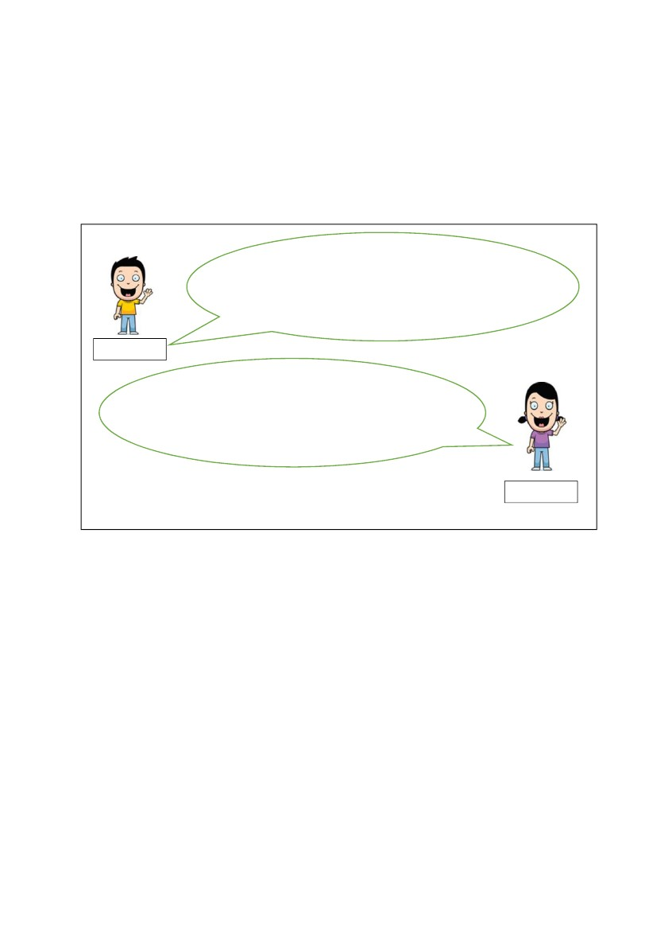
Section B
[ 15 marks ]
B (i)
Read the conversation below and answer the following question in the spaces provided.
Baca perbualan di bawah dan jawab soalan berikutnya di ruang yang disediakan.

My sister Elena and I are proud to have twenty
cousins. One of our cousins is celebrating his
birthday on 1st June. We can’t wait to see him
and the others at the birthday party.
Hadi
I don’t usually meet my uncles and aunts
because we live far from each other. Weddings
and Hari Raya are like our reunion events.
Elena
List three occasions from the dialogue that usually gather Hadi and Elena with their extended
family .
i.
ii.
iii.
_____________________________________________________________
_____________________________________________________________
______________________________________________________________
[ 3 marks]
3

B (ii)
Elena has a pen-pal named Suzzane from Sydney,Australia. She wants to tell Suzanne about
her extended family. Write an informal letter for Elena.
Write your answer between 50 to 80 words.
Elena mempunyai seorang sahabat pena bernama Suzanne dari Sydney,Australia . Dia
hendak memberitahu Suzanne tentang keluarga kembangannya. Tuliskan sepucuk surat tidak
rasmi untuk Elena.
Tulis jawapan kamu antara 50 hingga 80 patah perkataan.

__________________________
__________________________
__________________________
__________________________
__________________________
________________________ ,
___________________________________________________________________________
__________________________________________________________________________
___________________________________________________________________________
___________________________________________________________________________
___________________________________________________________________________
___________________________________________________________________________
4

___________________________________________________________________________
___________________________________________________________________________
___________________________________________________________________________
___________________________________________________________________________
___________________________________________________________________________
___________________________________________________________________________
___________________________________________________________________________
___________________________________________________________________________
___________________________________________________________________________
___________________________________________________________________________
___________________________________________________________________________
___________________________________________________________________________
___________________________________________________________________________
___________________________________________________________________________
___________________________________________________________________________
___________________________________________________________________________
___________________________________________________________________________
___________________________________________________________________________
________________________________________________________________________

________________________,
________________________
[12 marks]
5

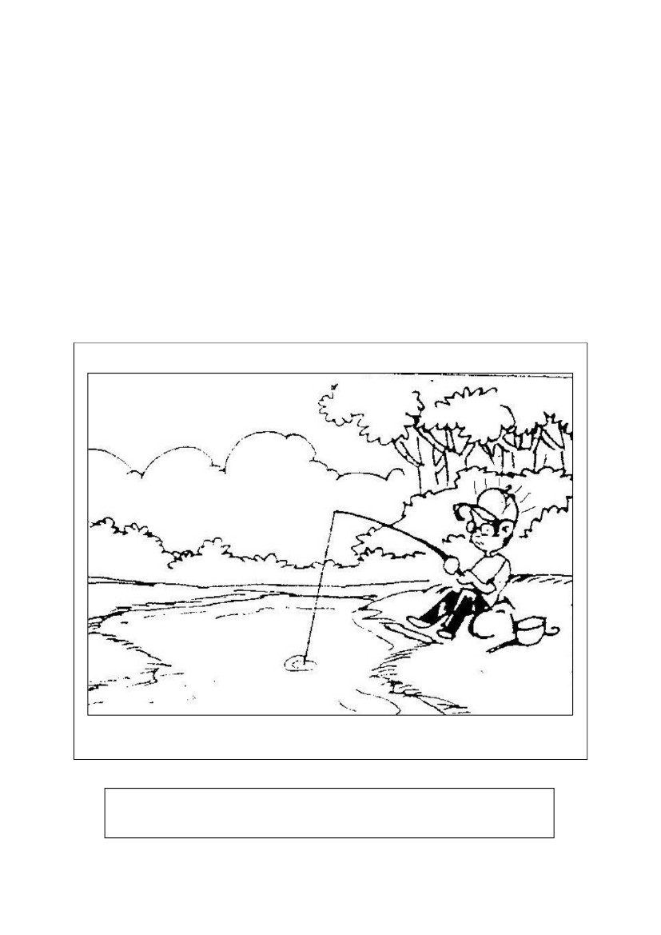
Section C
[25 marks]
This section consists of two questions. Answer one question only.
Bahagian ini mengandungi dua soalan. Jawab satu soalan sahaja.

Question 1
Write a story based on the picture below. You may use the words given to help you. Write
your answer in the space provided. Write your story between 80 to 100 words.
Tulis sebuah cerita berdasarkan gambar di bawah. Kamu boleh menggunakan perkataan-
perkataan yang diberikan untuk membantu kamu. Tulis jawapan kamu di ruang yang
disediakan. Panjangnya jawapan kamu hendaklah antara 80 hingga 100 patah perkataan.
lied – skipped – extra class – fishing – rod – baits – waited – big fish – no
fishes – angry - home – scolded – regretted - promised
Begin your story with this sentence:
6

Last Monday evening, Zaki lied to his mother. He….

___________________________________________________________________________
___________________________________________________________________________
___________________________________________________________________________
___________________________________________________________________________
___________________________________________________________________________
___________________________________________________________________________
___________________________________________________________________________
___________________________________________________________________________
___________________________________________________________________________
___________________________________________________________________________
___________________________________________________________________________
___________________________________________________________________________
___________________________________________________________________________
___________________________________________________________________________
___________________________________________________________________________
___________________________________________________________________________
___________________________________________________________________________
___________________________________________________________________________
___________________________________________________________________________
___________________________________________________________________________
___________________________________________________________________________
___________________________________________________________________________
___________________________________________________________________________
___________________________________________________________________________
7

___________________________________________________________________________
__________________________________________________________________________
__________________________________________________________________________
___________________________________________________________________________
___________________________________________________________________________
___________________________________________________________________________
___________________________________________________________________________
___________________________________________________________________________
___________________________________________________________________________
___________________________________________________________________________

8

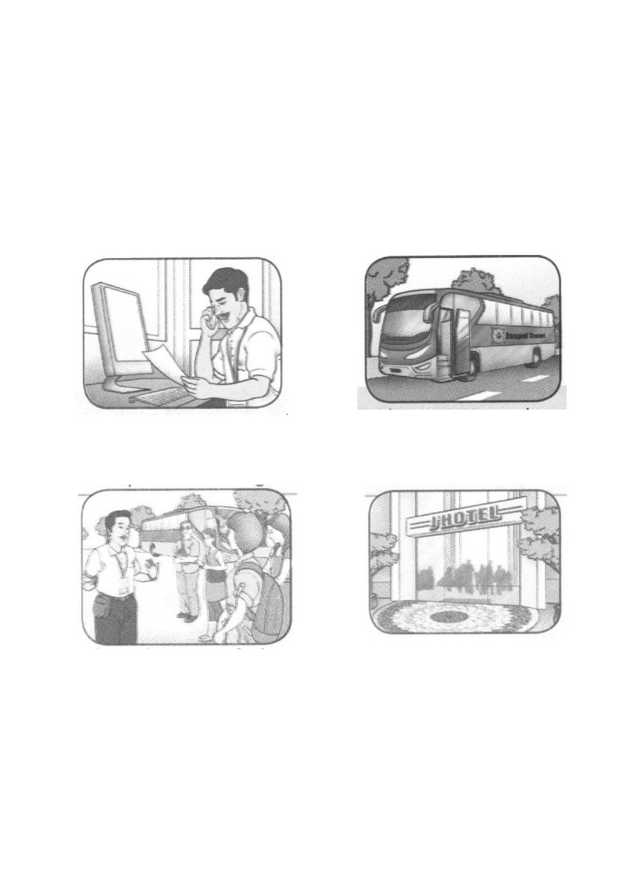
OR
Question 2

Write a story based on the pictures below. You may use the words given to help you. Write
your answer in the space provided. Write your story between 80 to 100 words.
Tulis sebuah cerita berdasarkan gambar-gambar di bawah. Kamu boleh menggunakan
perkataan-perkataan yang diberikan untuk membantu kamu. Tulis jawapan kamu di ruang
yang disediakan. Panjang jawapan kamu hendaklah antara 80 hingga 100 patah perkataan.
Mr Ranjit – tourist guide
took – tourists – bus
explained – history of places
sent - hotel – after - tour
9

___________________________________________________________________________
___________________________________________________________________________
___________________________________________________________________________
___________________________________________________________________________
___________________________________________________________________________
___________________________________________________________________________
___________________________________________________________________________
___________________________________________________________________________
___________________________________________________________________________
___________________________________________________________________________
___________________________________________________________________________
___________________________________________________________________________
___________________________________________________________________________
___________________________________________________________________________
___________________________________________________________________________
___________________________________________________________________________
___________________________________________________________________________
___________________________________________________________________________
___________________________________________________________________________
___________________________________________________________________________

___________________________________________________________________________
10

___________________________________________________________________________
__________________________________________________________________________
__________________________________________________________________________
___________________________________________________________________________
___________________________________________________________________________
___________________________________________________________________________
___________________________________________________________________________
___________________________________________________________________________
___________________________________________________________________________
___________________________________________________________________________

END OF PAPER
11

