SULIT

BAHASA INGGERIS
Kertas 2 - Penulisan
Tahun 1
Januari - Mei
2019
1$\frac{1}{4}$ jam

PENTAKSIRAN BILIK DARJAH (PBD) 2019
(JANUARI - MEI)
TAHUN 1

Nama : ……………………………………………………… Kelas : ………………………

BAHASA INGGERIS
Kertas 2 - Penulisan

Satu jam lima belas minit

JANGAN BUKA KERTAS SOALAN SEHINGGA DIBERITAHU

- Kertas soalan ini mengandungi tiga bahagian : Bahagian A, Bahagian B dan Bahagian C.
- Kamu dikehendaki menjawab ketiga-tiga bahagian.
- Bagi Bahagian C, kamu boleh memilih sama ada menjawab Soalan 1 atau Soalan 2.
- Jawapan kamu hendaklah ditulis pada ruang yang disediakan dalam kertas soalan ini.

Kertas soalan ini mengandungi 9 halaman bercetak

SECTION A
[10 marks]

Study the notes below and use the information to complete the following text.
Teliti rajah di bawah dan gunakan maklumat yang diberi untuk melengkapkan teks yang berikut.
The crescent moon and the star

Blue = unity

Yellow = the royal colour
White and red stripes

Red = bravery

White = purity

Our national flag is called Jalur Gemilang. There are fourteen stripes, seven red and seven white. The rectangle is ________________ (1). The crescent moon and the star are _________________________ (2). Blue means unity among people. Yellow is the ___________________ (3). Red means _____________________ (4) and white means ____________________________ (5).
SECTION B
[15 marks]
B(i)
Study the pictures and information given.
Teliti gambar-gambar dan maklumat yang diberikan.

Amar has three books, two pencils, one rubber and one ruler.
Lili has one book, two rubbers, one pencil and one ruler.
Kamelia has three pencils, two books, one rubber and one ruler.
Hakim has four books, four pencils, one rubber and two rulers.

B(i)
Fill in the blanks with the correct answers. One has been done for you.
Isikan tempat kosong dengan jawapan yang betul. Satu daripadanya telah ditunjukkan sebagai contoh.

Name | Items
Amar | ______Three_____ books
Lili | (i) _______________ rubbers
Kamelia | (ii) _______________ pencils
Hakim | (iii) _______________ rulers
[3 marks]

B(ii)
You are new in class. Your teacher wants you to introduce yourself. Write a letter to tell about yourself and items you bring to school.
Write your message between 30 and 50 words.
Kamu murid baru. Guru kamu mahu kamu memperkenalkan diri. Tulis satu surat tentang diri kamu dan peralatan yang kamu bawa ke sekolah.

Hi ___________________,

My name is_________________________________.

__________________________________years old.

I am ___________________________________.

I like to play ____________________________.

I bring ___________________________________________________________________________

__________________________________________________________________________________

__________________________________________________________________________________

to school.

[12 marks]

SECTION C
[25 marks]

This section consists of two questions. Answer one question only.
Bahagian ini mengandungi dua soalan. Jawab satu soalan sahaja.

Question 1
Rearrange the phrases and create a sentence. Write your answers in the space given.
Susun perkataan dan bina ayat. Tulis jawapan anda di ruang yang diberikan.

friends
Balqis, Sofea and Ain
are

1)_______________________________________________________________________.

They
seven
are
years old

2)_________________________________________________________________________.

to play
together
They like

3)_________________________________________________________________________.

likes
with dolls
to play
Balqis

4)_________________________________________________________________________.

doll
blue
Balqis
has a
pretty

5)________________________________________________________________________.

doll
Ain
doesn’t
like

6)_________________________________________________________________________.

pink plane
Is a
toy
Ain
favourite
OR

7)_________________________________________________________________________.

planes
and
like
Sofea
dolls

8)________________________________________________________________________.

OR

Question 2
Look at the picture. Match the words in Column A to the words in Column B. Write your answers in the space given.
Lihat gambar. Suaikan perkataan dari kolum A dengan kolum B. Tulis jawapan anda di ruangan yang disediakan.

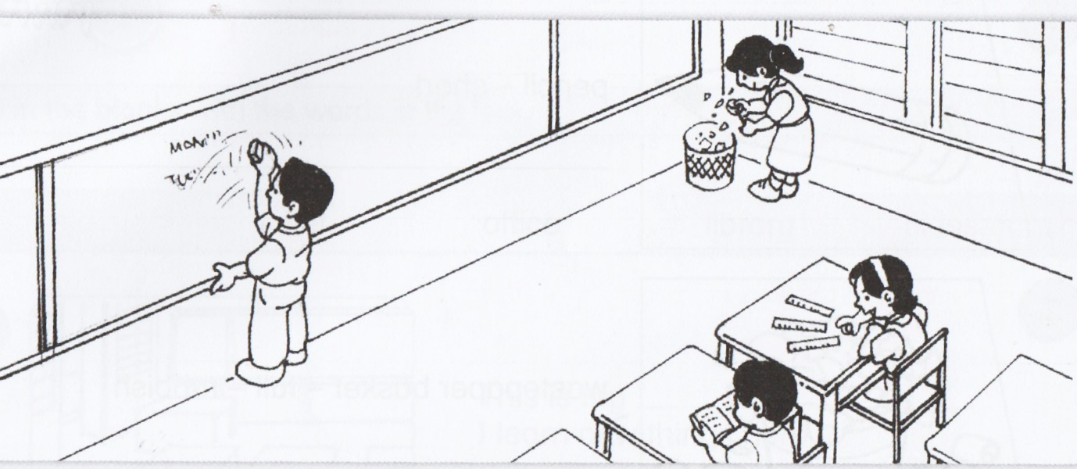

Column A Column B
her pencil
The children are

Anis has
a book
three rulers
the blackboard
in the classroom

Mala is sharpening

Sufi is reading

Adam is cleaning

__________________________________________________________________________________

__________________________________________________________________________________

__________________________________________________________________________________

__________________________________________________________________________________

__________________________________________________________________________________

__________________________________________________________________________________

__________________________________________________________________________________

__________________________________________________________________________________

__________________________________________________________________________________

__________________________________________________________________________________

__________________________________________________________________________________

__________________________________________________________________________________

__________________________________________________________________________________

__________________________________________________________________________________

__________________________________________________________________________________

__________________________________________________________________________________

__________________________________________________________________________________

__________________________________________________________________________________

__________________________________________________________________________________

__________________________________________________________________________________

__________________________________________________________________________________

__________________________________________________________________________________

__________________________________________________________________________________

__________________________________________________________________________________

__________________________________________________________________________________

__________________________________________________________________________________

__________________________________________________________________________________

__________________________________________________________________________________

__________________________________________________________________________________

__________________________________________________________________________________

__________________________________________________________________________________

__________________________________________________________________________________

__________________________________________________________________________________

__________________________________________________________________________________

__________________________________________________________________________________

__________________________________________________________________________________

__________________________________________________________________________________

__________________________________________________________________________________

__________________________________________________________________________________

__________________________________________________________________________________

__________________________________________________________________________________

__________________________________________________________________________________

__________________________________________________________________________________

__________________________________________________________________________________

__________________________________________________________________________________

__________________________________________________________________________________

__________________________________________________________________________________

__________________________________________________________________________________

End of question

ANSWER SCHEME
SECTION A
- blue
- yellow
- royal colour
- bravery
- purity

SECTION B

B(i)

- two
- three
- two

B(ii)

Hi class,

My name is Aminah.

I am seven years old.

I am a girl.

I like to play kite.

I bring one pencil, two rulers and four rubbers to school.

SECTION C
Question 1
1) Balqis, Ain, Sofea are friends.
2) They are seven years old.
3) They like to play together.
4) Balqis likes to play with dolls.
5) Balqis has a pretty blue doll.
6) Ain doesn’t like dolls.
7) Ain favourite toy is a pink plane.
8) Sofea likes dolls and planes.
Question 2

Column A Column B
her pencil
The children are

Anis has
a book
three rulers
the blackboard
in the classroom

Mala is sharpening

Sufi is reading

Adam is cleaning

The children are in the classroom.
Anis has three rulers.
Mala is sharpening her pencils.
Sufi is reading a book.
Adam is cleaning the blackboard.

ISI KANDUNGAN SOALAN

SECTION | TOPIC | ASPECT
A | Friends | Information transfers
B | At school | Information transfers
C | Friends/at school | Writing
 | At school/let’s play | Writing

A) CARA PENGIRAAN MARKAH:

- Kertas 2 : Bahagian A (10 markah) + Bahagian B (15 markah) + Bahagian C (25 markah)
- Markah penuh = 50 markah x 2 = 100 markah

B) JULAT MARKAH & TAHAP PENGUASAAN (TP):

Markah | Tahap Penguasaan (TP)
0 - 39 | TP 1
40 - 50 | TP 2
51 - 60 | TP 3
61 - 70 | TP 4
71 - 80 | TP 5
81 - 100 | TP 6

C) PENILAIAN OLEH GURU:

- Kemahiran & Proses (TP 1 hingga TP 6)
- Sikap & Nilai (TP 1 hingga TP 6)

Kedua-dua elemen di atas akan dinilai oleh guru yang mengajar mata pelajaran ini.

D) TAHAP PENGUASAAN KESELURUHAN

Item B dan C dijumlahkan.

