SULIT

BAHASA INGGERIS
Kertas 2 - Penulisan
Tahun 1
Mei
2018
1$\frac{1}{4}$ jam

PENTAKSIRAN PERTENGAHAN TAHUN 2018
TAHUN 1

Nama : ……………………………………………………… Kelas : ………………………

BAHASA INGGERIS
Kertas 2 - Penulisan

Satu Jam lima belas minit

JANGAN BUKA KERTAS SOALAN SEHINGGA DIBERITAHU

- Kertas soalan ini mengandungi tiga bahagian : Bahagian A, Bahagian B dan Bahagian C.
- Kamu dikehendaki menjawab ketiga-tiga bahagian.
- Bagi Bahagian C, kamu boleh memilih sama ada menjawab Soalan 1 atau Soalan 2.
- Jawapan kamu hendaklah ditulis pada ruang yang disediakan dalam kertas soalan ini.

Kertas soalan ini mengandungi 7 halaman bercetak

SECTION A
[10 marks]

Look at the picture below and complete the following text with the correct answers.
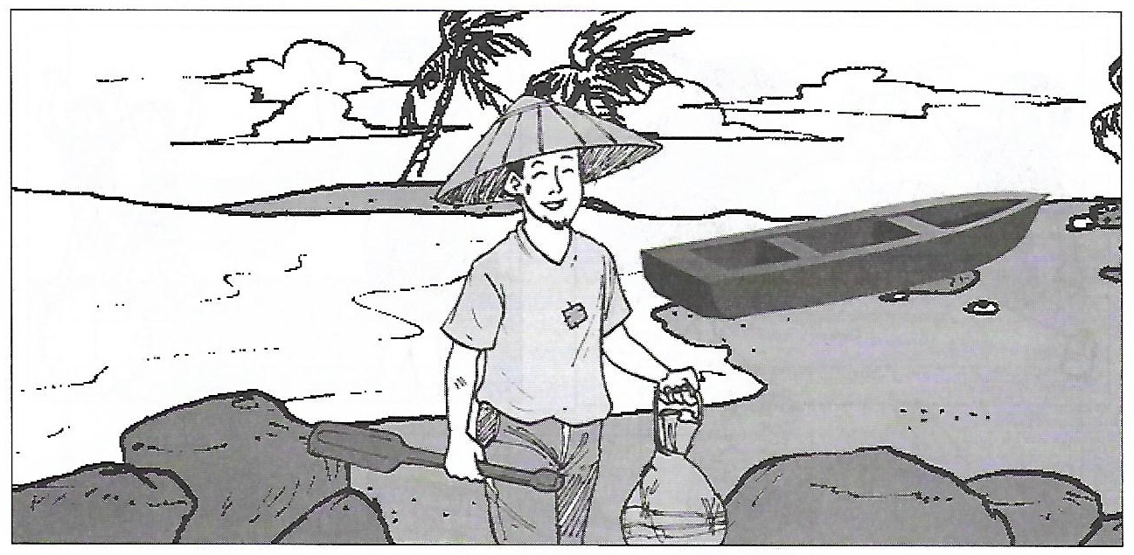

fisherman
shore
lives
sea
crabs

Rahim is a (1) _________________________. He (2) __________________________ in Kampung Besut. Every day, all the fishermen from Kampung Besut will go to the (3) __________________________ to catch fish. They always come back with a lot of (4) __________________________, fish, prawns and squids.
Many people will be waiting at the (5) ______________________________ to buy their catch.

SECTION B
[15 marks]

Study the pictures and the information given.
Teliti gambar-gambar dan maklumat yang diberi.

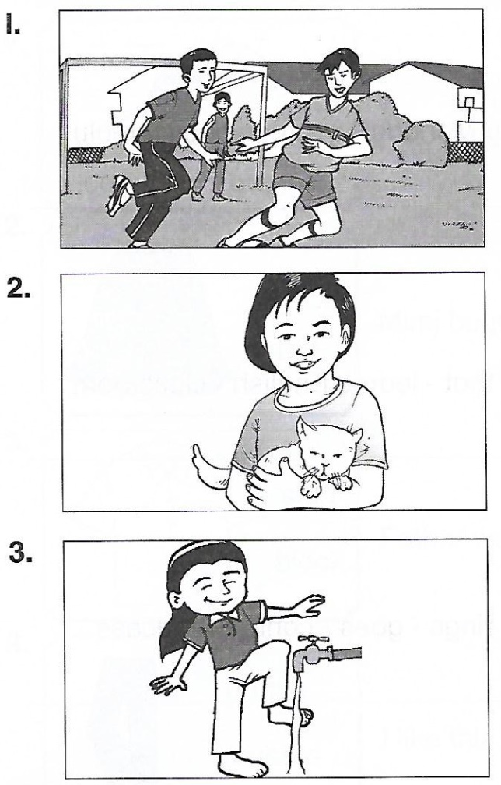
She - washing - feet
cat - long - tail
boys - playing - football

B (i)
Fill in the blanks with the correct answers. One has been done for you.
Isikan tempat kosong dengan jawapan yang betul. Satu daripadanya telah ditunjukkkan sebagai contoh.

Picture | Name of living things
1 | i)___________________________________________
2 | ii) __________________________________________  iii) Girl
3 | iv) _________________________________________

[3 marks]
B (ii)
Based on information given, write a sentence for each picture.
Berdasarkan maklumat yang diberi, tuliskan ayat bagi setiap gambar.

Picture 1:

____________________________________________________________________________________________________________________________________________________________________
[4 marks]
Picture 2:

____________________________________________________________________________________________________________________________________________________________________
[4 marks]
Picture 3:

____________________________________________________________________________________________________________________________________________________________________
[4 marks]

SECTION C
[25 marks]

This section consist of two questions. Answer one question only.
Bahagian ini mengandungi dua soalan. Jawab satu soalan sahaja.

Question 1
Underline the correct answer. Then, rewrite the sentences in the spaces to form a story.
Gariskan jawapan yang betul. Kemudian, tulis semula ayat-ayat tersebut untuk membentuk sebuah cerita.

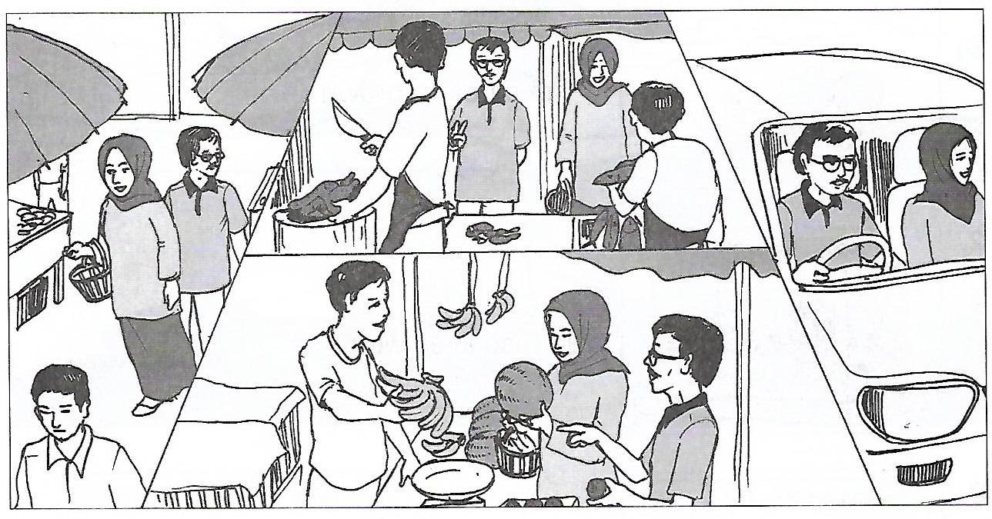

- Puan Aina and her husband are at the (shop / market).

- They go to the market by (bus / car).

- They are buying some fish and (chicken / prawn).

- They also buy some fruits like (rambutans / bananas), (durians / oranges) and watermelon.

Puan Aina and her husband are at the ________________________________________________________________________________________________________________________________________________________________________________________________________________________________________________________________________________________________________________________________________________________________________________________________________________________________________________________________________________________________________________________________________________________________________________________________________________________________________________________________________________

OR
Question 2
Look at the map and arrange the sentences in order. Then, rewrite the sentences in a paragraph.
Lihat peta dan susun ayat-ayat dalam susunan yang betul. Kemudian, tulis semula ayat-ayat tersebut dalam satu perenggan.
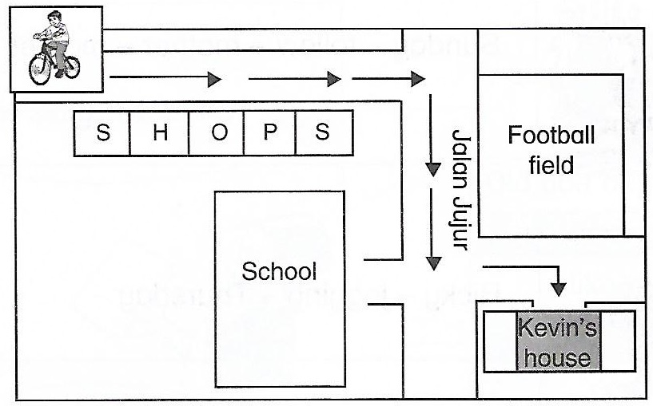

- He wants to go to Kevin’s house. ( )
- Then, he turns right into Jalan Jujur. ( )
- Aiman is riding his bicycle. ( 1 )
- After the field, he turns left and stops at Kevin’s house. ( )
- First, he cycles past some shops. ( 3 )
- He sees a school on the right and a football field on the left. ( )
Write the sentences in a paragraph.

_________________________________________________________________________________________________________________________________________________________________________________________________________________________________________________________________________________________________________________________________________________________________________________________________________________________________________________________________________________________________________________________________________________________________________________________________________________________________________________________________________________________________________________________________________________________________________________________________________________________________________________________________________________________________________________________________________________________________________________________________________________________________________________________________________________________________________________________________________________________________________________________________________________________________________________________________________________________________________________________________________________________________________________________________________________________________________________________________________________________________________________________________________________________________________________________________________________________________________________________________________________________________

End of question

ANSWER SCHEME
Section A
- fisherman
- lives
- sea
- crabs
- shore

Section B
B (i)
i) boys
iii) cat
iv) girl

B (ii)

Picture 1 : The boys are playing football.

Picture 2 : The cat has a long tail.

Picture 3 : She is washing her feet.

Section C

Question 1

- market
- car
- chicken
- bananas, oranges

Puan Aina and her husband are at the market. They go to the market by car. They are buying some fish and chicken. They also buy some fruits like bananas, oranges and watermelon.

Question 2

- Aiman is riding his bicycle.
- He wants to go to Kevin’s house.
- First, he cycles past some shops.
- Then, he turns right into Jalan Jujur.
- He sees a school on the right and a football field on the left.
- After the field, he turns left and stops at Kevin’s house.

Aiman is riding his bicycle. He wants to go to Kevin’s house. First, he cycles past some shops. Then, he turns right into Jalan Jujur. He sees a school on the right and a football field on the left. After the field, he turns left and stops at Kevin’s house.

