SULIT

BAHASA INGGERIS
Kertas 2 - Penulisan
Tahun 1
Oktober
2017
1$\frac{1}{4}$ jam

PEPERIKSAAN AKHIR TAHUN 2017
TAHUN 1

Nama : ……………………………………………………… Kelas : ………………………

BAHASA INGGERIS
Kertas 2 - Penulisan

Satu Jam lima belas minit

JANGAN BUKA KERTAS SOALAN SEHINGGA DIBERITAHU

- Kertas soalan ini mengandungi tiga bahagian : Bahagian A, Bahagian B dan Bahagian C.
- Kamu dikehendaki menjawab ketiga-tiga bahagian.
- Bagi Bahagian C, kamu boleh memilih sama ada menjawab Soalan 1 atau Soalan 2.
- Jawapan kamu hendaklah ditulis pada ruang yang disediakan dalam kertas soalan ini.

Kertas soalan ini mengandungi 7 halaman bercetak

SECTION A
[10 marks]

Study the mind map below and use the information to complete the following text.
Berdasarkan peta minda yang diberi, lengkapkan teks di bawah dengan maklumat yang betul.

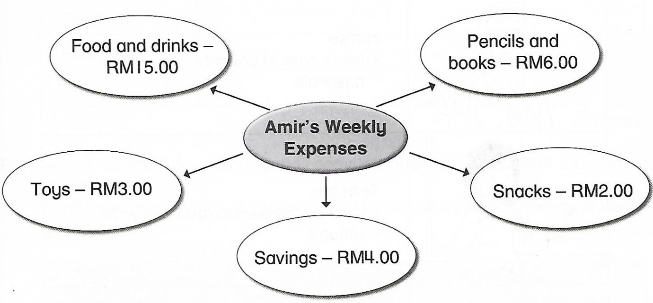

Last week, Amir’s father gave him RM30.00 for his weekly expenses. Amir used the money smartly. He spent RM15.00 on food and (1) _________________ at school. He bought pencils and (2) _________________ at the bookshop. They cost (3)
RM __________________ altogether. Amir used (4) RM __________________ to buy toys and another RM2.00 for snacks. He saved (5) RM __________________ at the end of the week.

SECTION B
[15 marks]

Study the pictures and the information given.
Teliti gambar-gambar dan maklumat yang diberi.

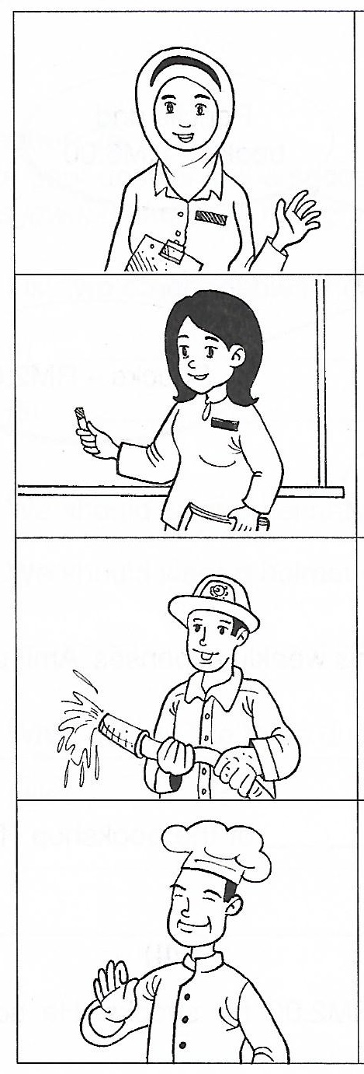

Nurse
- takes care of patients
- hospitals

Teacher
- teaches children to read and write
- schools

Firefighter
- puts out fires
- fire stations

Chef
- cooks delicious food
- restaurant

B (i)
Fill in the blanks with the correct answers. One has been done for you.
Isikan tempat kosong dengan jawapan yang betul. Satu daripadanya telah ditunjukkkan sebagai contoh.

Occupation | What they do
Nurse | Takes care of patients.
Teacher | Teaches children to read and ________________.
Firefighter | Puts out _______________.
Chef | Cooks delicious ________________.

[3 marks]

B (ii)
Based on information given, complete the text below with the correct answers.
Berdasarkan maklumat yang diberi, lengkapkan teks di bawah dengan jawapan yang betul.

station
fires
teacher
write
restaurant
hospital

A chef cooks in a (1) _________________________. A firefighter works at a fire (2) ______________________. He puts out (3) _______________________. Meanwhile a nurse works at a (4) _______________________. However, I would like to be a (5) _____________________ so that I can teach children to read and (6) _____________________.
[12 marks]

SECTION C
[25 marks]

This section consist of two questions. Answer one question only.
Bahagian ini mengandungi dua soalan. Jawab satu soalan sahaja.

Question 1
Underline the correct answer. Then, rewrite the sentences in the spaces to form a story.
Gariskan jawapan yang betul. Kemudian, tulis semula ayat-ayat tersebut untuk membentuk sebuah cerita.

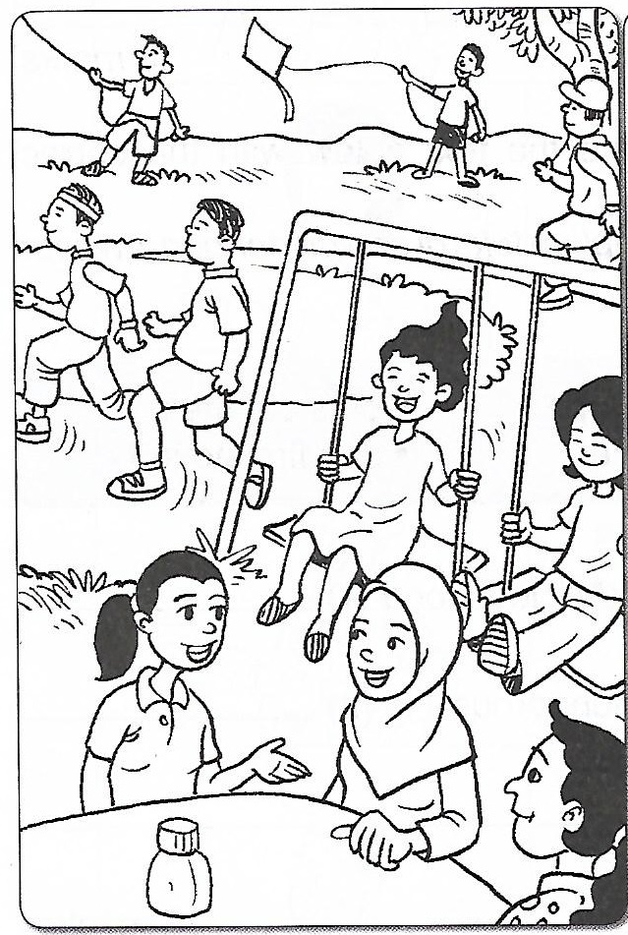
- They are many people at the (park/field).

- A few man are (cycling/jogging) in the park.

- Some boys are flying (kites/balloons).

- Two girls are playing on the (slide/swings).

- A few ladies are (chatting/dancing) happily.

They are many people at the ___________________________________________________
__________________________________________________________________________________
__________________________________________________________________________________
__________________________________________________________________________________
__________________________________________________________________________________

Question 2
Look at the pictures. Underline the correct answer. Then, rewrite the sentences in three paragraphs.
Lihat gambar-gambar. Gariskan jawapan yang betul. Kemudian, tulis semula ayat-ayat tersebut dalam tiga perenggan.

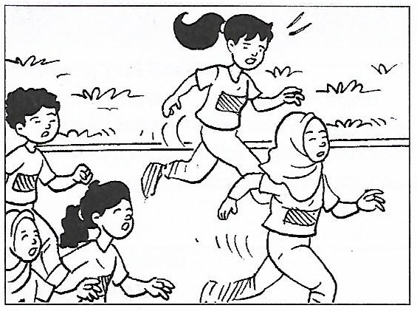
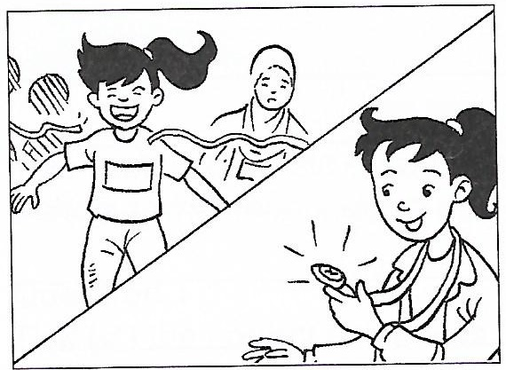
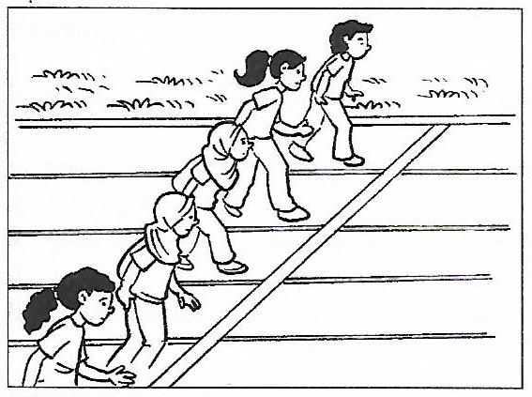
First Paragraph

It is Sports Day at Ayu’s (school/home). Ayu is taking part in the 100 metre (run/jump). There are (five/seven) runners altogether.

Second Paragraph

The race starts and they (run/jump) as fast as they can. Ayu is in (last/first) place. She runs (faster/slower) and manages to be in first place.

Third Paragraph

In the end, she is the (first/second) to reach the finish line. She (win/lost) the race and gets a gold medal. She is very (happy/sad).

It is Sports Day at Ayu’s ___________________________________________________
_________________________________________________________________________________________________________________________________________________________________________________________________________________________________________________
The race starts and they _________________________________________________
_________________________________________________________________________________________________________________________________________________________________________________________________________________________________________________
In the end, she is the _____________________________________________________
_________________________________________________________________________________________________________________________________________________________________________________________________________________________________________________

- End of question –

ANSWER SCHEME

SECTION A
- drinks
- books
- RM6.00
- RM3.00
- RM4.00

SECTION B

B (i)

- write

- fires

- food

B (ii)

- restaurant
- station
- fires
- hospital
- teacher
- write

SECTION C

Question 1

- park

- jogging

- kites

- swings

- chatting

They are many people at the park. A few man are jogging in the park. Some boys are flying kites. Two girls are playing on the swings. A few ladies are chatting happily.

Question 2

First Paragraph:
- school

- run

- five

Second Paragraph:
- run

- first

- faster

Third Paragraph:
- first

- win

- happy

It is Sports Day at Ayu’s school. Ayu is taking part in the 100 metre run. There are five runners altogether.
The race starts and they run as fast as they can. Ayu is in first place. She runs faster and manages to be in first place.
In the end, she is the first to reach the finish line. She win the race and gets a gold medal. She is very happy.

