SULIT

BAHASA INGGERIS
Kertas 2 - Penulisan
Tahun 3
Januari - Mei
2019
1$\frac{1}{4}$ jam

PENTAKSIRAN BILIK DARJAH (PBD) 2019
(JANUARI - MEI)
TAHUN 3

Nama : ……………………………………………………… Kelas : ………………………

BAHASA INGGERIS
Kertas 2 - Penulisan

Satu jam lima belas minit

JANGAN BUKA KERTAS SOALAN SEHINGGA DIBERITAHU

- Kertas soalan ini mengandungi tiga bahagian : Bahagian A, Bahagian B dan Bahagian C.
- Kamu dikehendaki menjawab ketiga-tiga bahagian.
- Bagi Bahagian C, kamu boleh memilih sama ada menjawab Soalan 1 atau Soalan 2.
- Jawapan kamu hendaklah ditulis pada ruang yang disediakan dalam kertas soalan ini.

Kertas soalan ini mengandungi 9 halaman bercetak

SECTION A
[10 marks]

Study the notes below and use the information to complete the following text.
Teliti rajah di bawah dan gunakan maklumat yang diberi untuk melengkapkan teks yang berikut.

Sarah
Iqram
Brown hair
Brown eyes
Shirt
Boy
curly hair
blue eyes
trainer
girl

Iqram and Sarah are siblings. Sarah has got __________________(1) and curly hair. She is a pretty __________________(2). She likes to wear ___________________(3). Iqram has got ___________________(4) hair and brown eyes. He is a nice boy. He likes to wear ______________(5). Sarah and Iqram always play together. Their favourite sport is badminton.
SECTION B
[15 marks]
B(i)
Study the pictures and information given.
Teliti gambar-gambar dan maklumat yang diberikan.

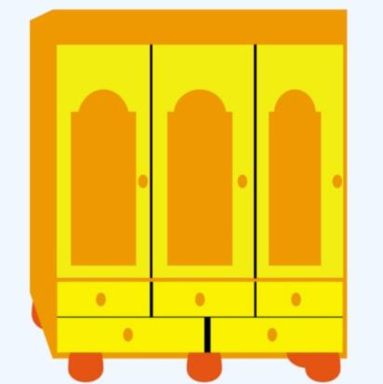 | Cupboard  -yellow  -in the living room, kitchen or bedroom  -store any items  -big and spacious
Armchair

-red
-in the living room or bedroom
-sit and relaxing
-small

Bookcase

-brown
-in the bedroom or living room
-store book
-big and spacious

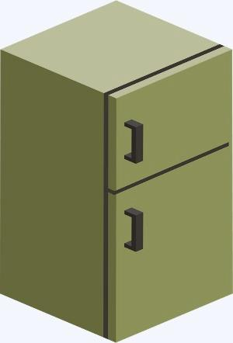 | Fridge  -green  -in the kitchen  -can put drinks and store foods  -big

B(i)
Fill in the blanks with the correct answers. One has been done for you.
Isikan tempat kosong dengan jawapan yang betul. Satu daripadanya telah ditunjukkan sebagai contoh.

Item | Place
Cupboard | in the living room, kitchen or bedroom
Armchairs | i)_____________________________________
Bookcase | ii)_____________________________________
Fridge | iii)_____________________________________
[3 marks]

B(ii)
Your mother wanted to choose a new furniture or electronic device to put in your house. Write your choices to her. You may include details such as place to put, size, colour, function or any other useful information.
Write your message between 50 and 80 words.
Ibu kamu mahu membeli perkakas baru di rumah. Tulis satu pesanan untuk memberitahu ibu tentang pilihan kamu. Kamu boleh menambah maklumat seperti tempat,saiz, warna, kegunaan, dan perkara lain yang sesuai. Panjangnya jawapan kamu hendaklah antara 50 hingga 80 patah perkataan.

Dear___________________,

I would like to ____________________________________________________________
_____________________________________________________________________________________________________________________________________________________________________________________________________________________________________________________________________________________________________________________________________________________________________________________________________________________________________________________________________________________________________________________________________________________________________________________________
[12 marks]

