SULIT

BAHASA INGGERIS
Kertas 2 - Penulisan
Tahun 2
Mei
2018
1$\frac{1}{4}$ jam

PENTAKSIRAN PERTENGAHAN TAHUN 2018
TAHUN 2

Nama : ……………………………………………………… Kelas : ………………………

BAHASA INGGERIS
Kertas 2 - Penulisan

Satu Jam lima belas minit

JANGAN BUKA KERTAS SOALAN SEHINGGA DIBERITAHU

- Kertas soalan ini mengandungi tiga bahagian : Bahagian A, Bahagian B dan Bahagian C.
- Kamu dikehendaki menjawab ketiga-tiga bahagian.
- Bagi Bahagian C, kamu boleh memilih sama ada menjawab Soalan 1 atau Soalan 2.
- Jawapan kamu hendaklah ditulis pada ruang yang disediakan dalam kertas soalan ini.

Kertas soalan ini mengandungi 7 halaman bercetak

SECTION A
[10 marks]

Study the notes below and use the information to complete the text.
Teliti nota-nota di bawah dan ginakan maklumat yang diberi untuk melengkapkan teks.
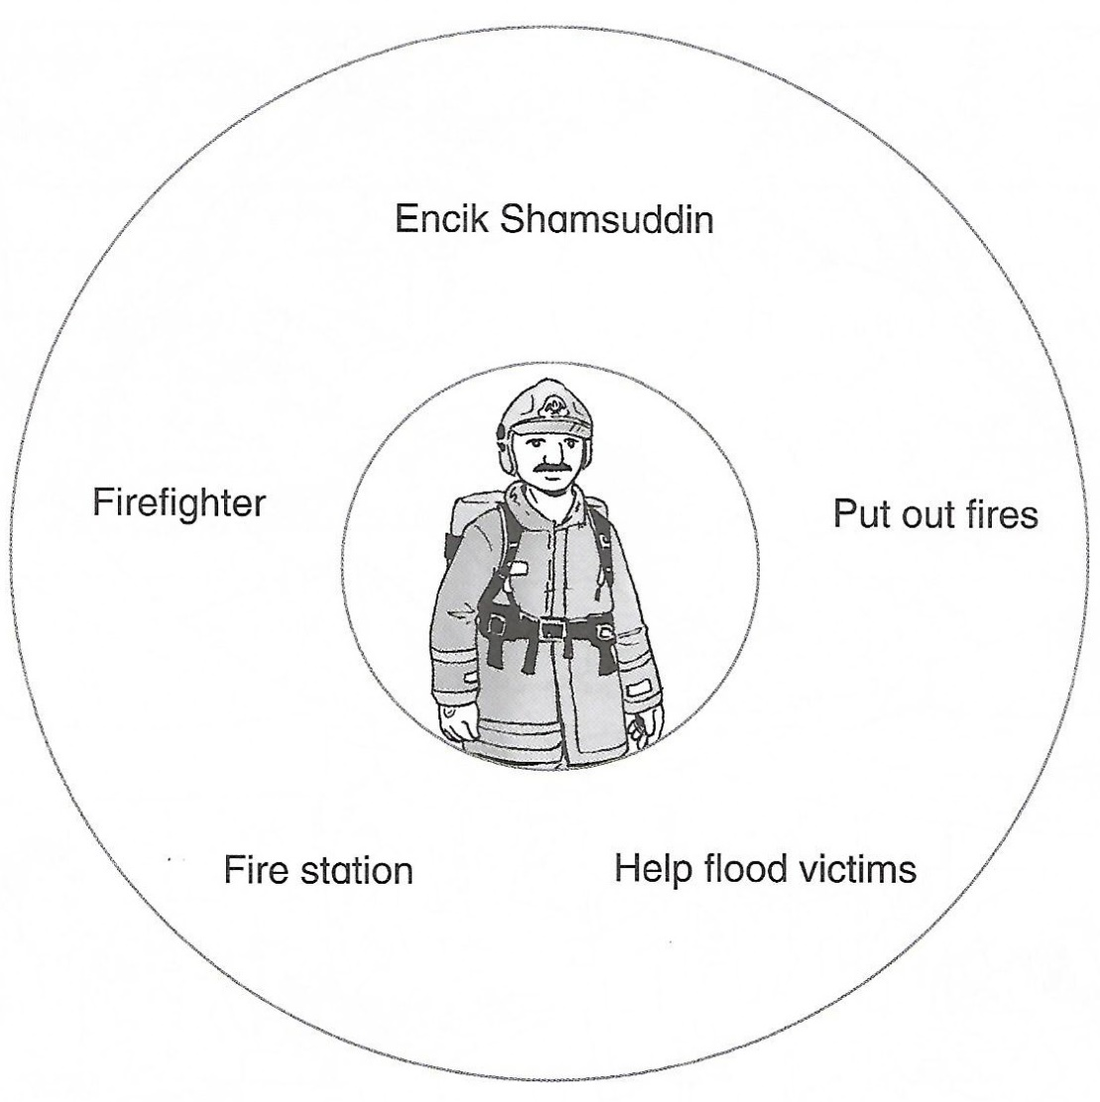

My name is (1) _______________________________________. I work as a (2) ________________________________________. I (3) ___________________________________ fires and help (4) ___________________________________. I work in a (5) _______________________________________.

SECTION B
[15 marks]

B(i)
Study the poster below and answer the following questions in the space provided.
Teliti poster di bawah dan jawab soalan-soalan yang berikutnya di ruang yang disediakan.

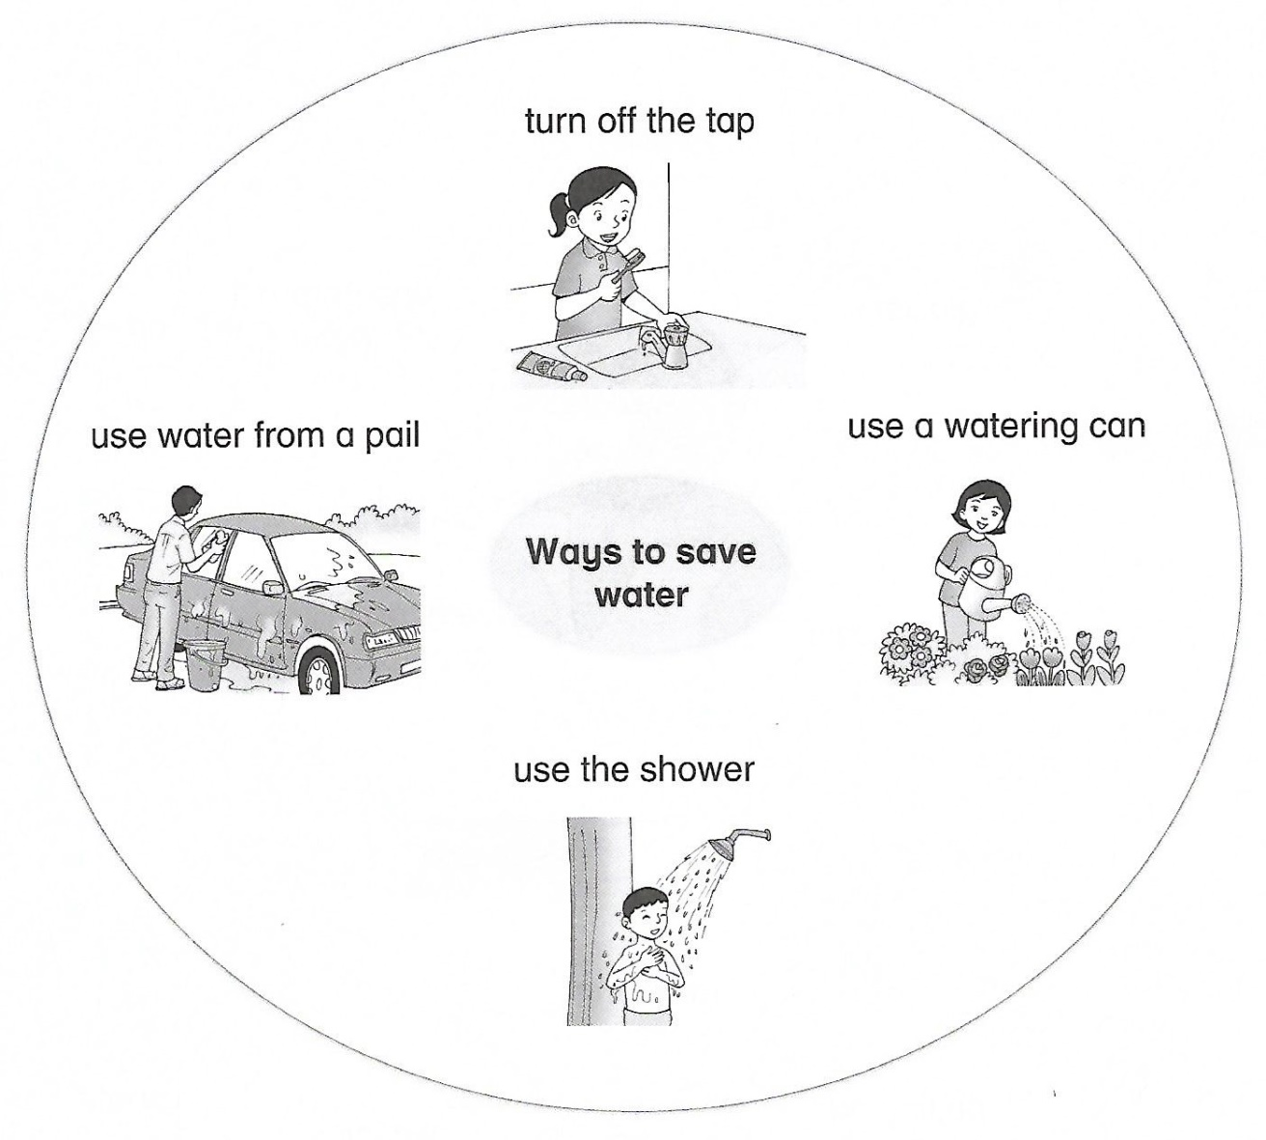

List three ways to save water.

- _________________________________________ while brushing your teeth.
- _________________________________________ to water plants.
- _________________________________________ to bathe.
[3 marks]

B(ii)
You received an email from your friend saying that the beach near her town is full of rubbish. Many sea creatures have died. Complete an email to your friend to tell her ways to save the sea creatures.
Anda menerima e-mel dari rakan anda mengatakan bahawa pantai berhampiran bandarnya penuh dengan sampah. Banyak hidupan laut telah mati. Lengkapkan e-mel kepada rakan anda untuk memberitahu cara untuk menyelamatkan hidupan laut.

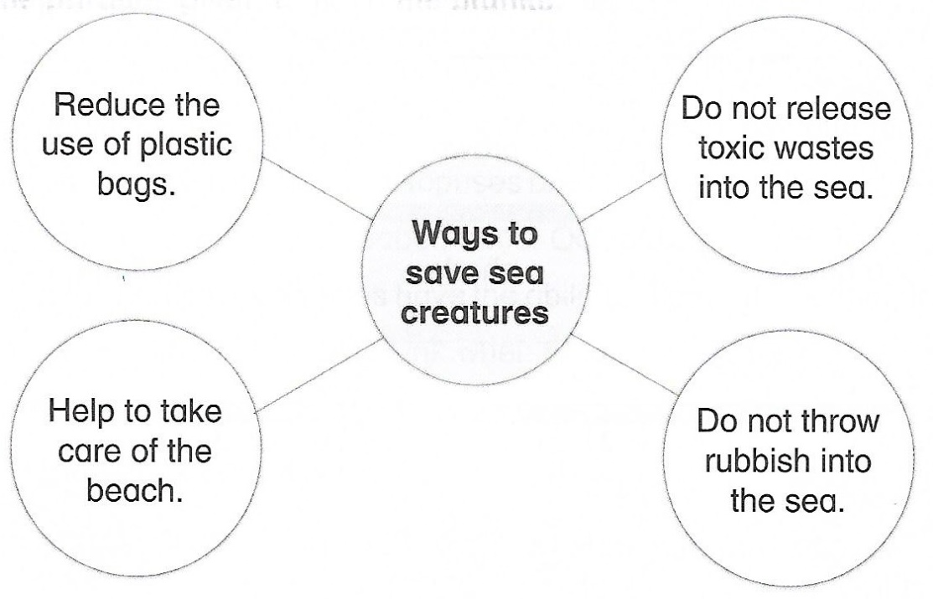

From : aaira@gmail.com | Date : 15 May 2018
To : aidill@gmail.com | Time : 2:00 p.m.
Subject : Ways to save the sea creatures
Dear Aidill,

I have read your email that many sea creatures have died. We should (1) ____________________________________________________________. We must help (2) ____________________________________________________________. We must not (3) ____________________________________________________________. The factories should not (4) _______________________________________________________________________ into the sea.

[12 marks]

SECTION C
[25 marks]

This section consists of two questions. Answer one question only.
Bahagian ini mengandungi dua soalan. Jawab satu soalan sahaja.

Question 1
Study the steps below and use the information given to complete the text with the correct information.
Teliti langkah-langkah di bawah dan gunakan maklumat yang diberi untuk melengkapkan teks dengan maklumat yang betul.

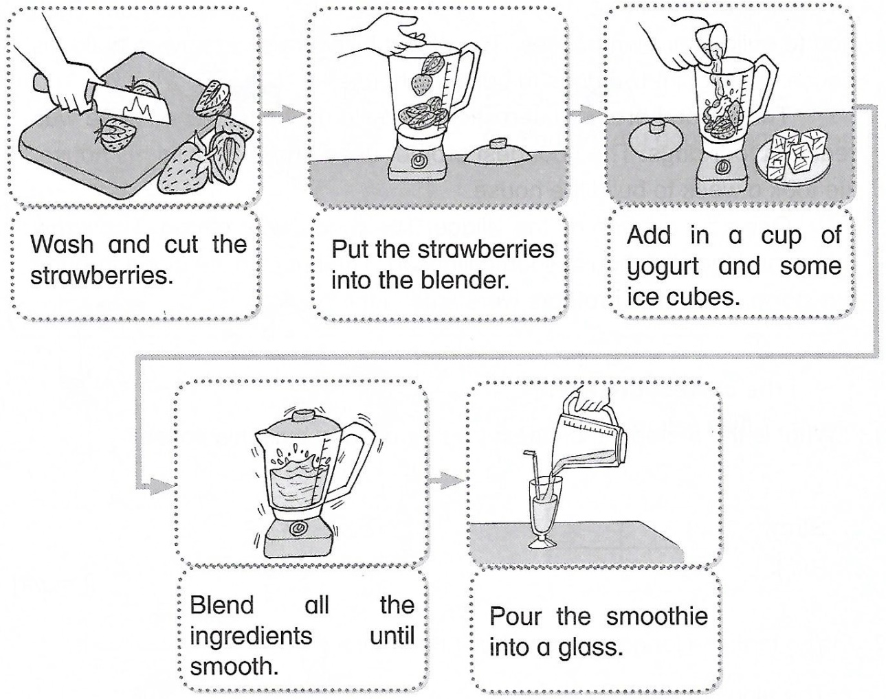
There are five steps to make a glass of strawberry smoothie. First, you need to (1) ___________________________________________________________________________. Next, (2)______________________________________________________________________into the blender. Then, add in a cup of yogurt and (3)_________________________________. Blend (4)_______________________________________________________________. Finally, (5) _____________________________________________________________________________.
OR

Question 2
Look at the picture below. Match the phrases given and write a story in a paragraph.
Perhatikan gambar di bawah. Padankan frasa-frasa yang diberikan dan tulis sebuah cerita dalam satu perenggan.
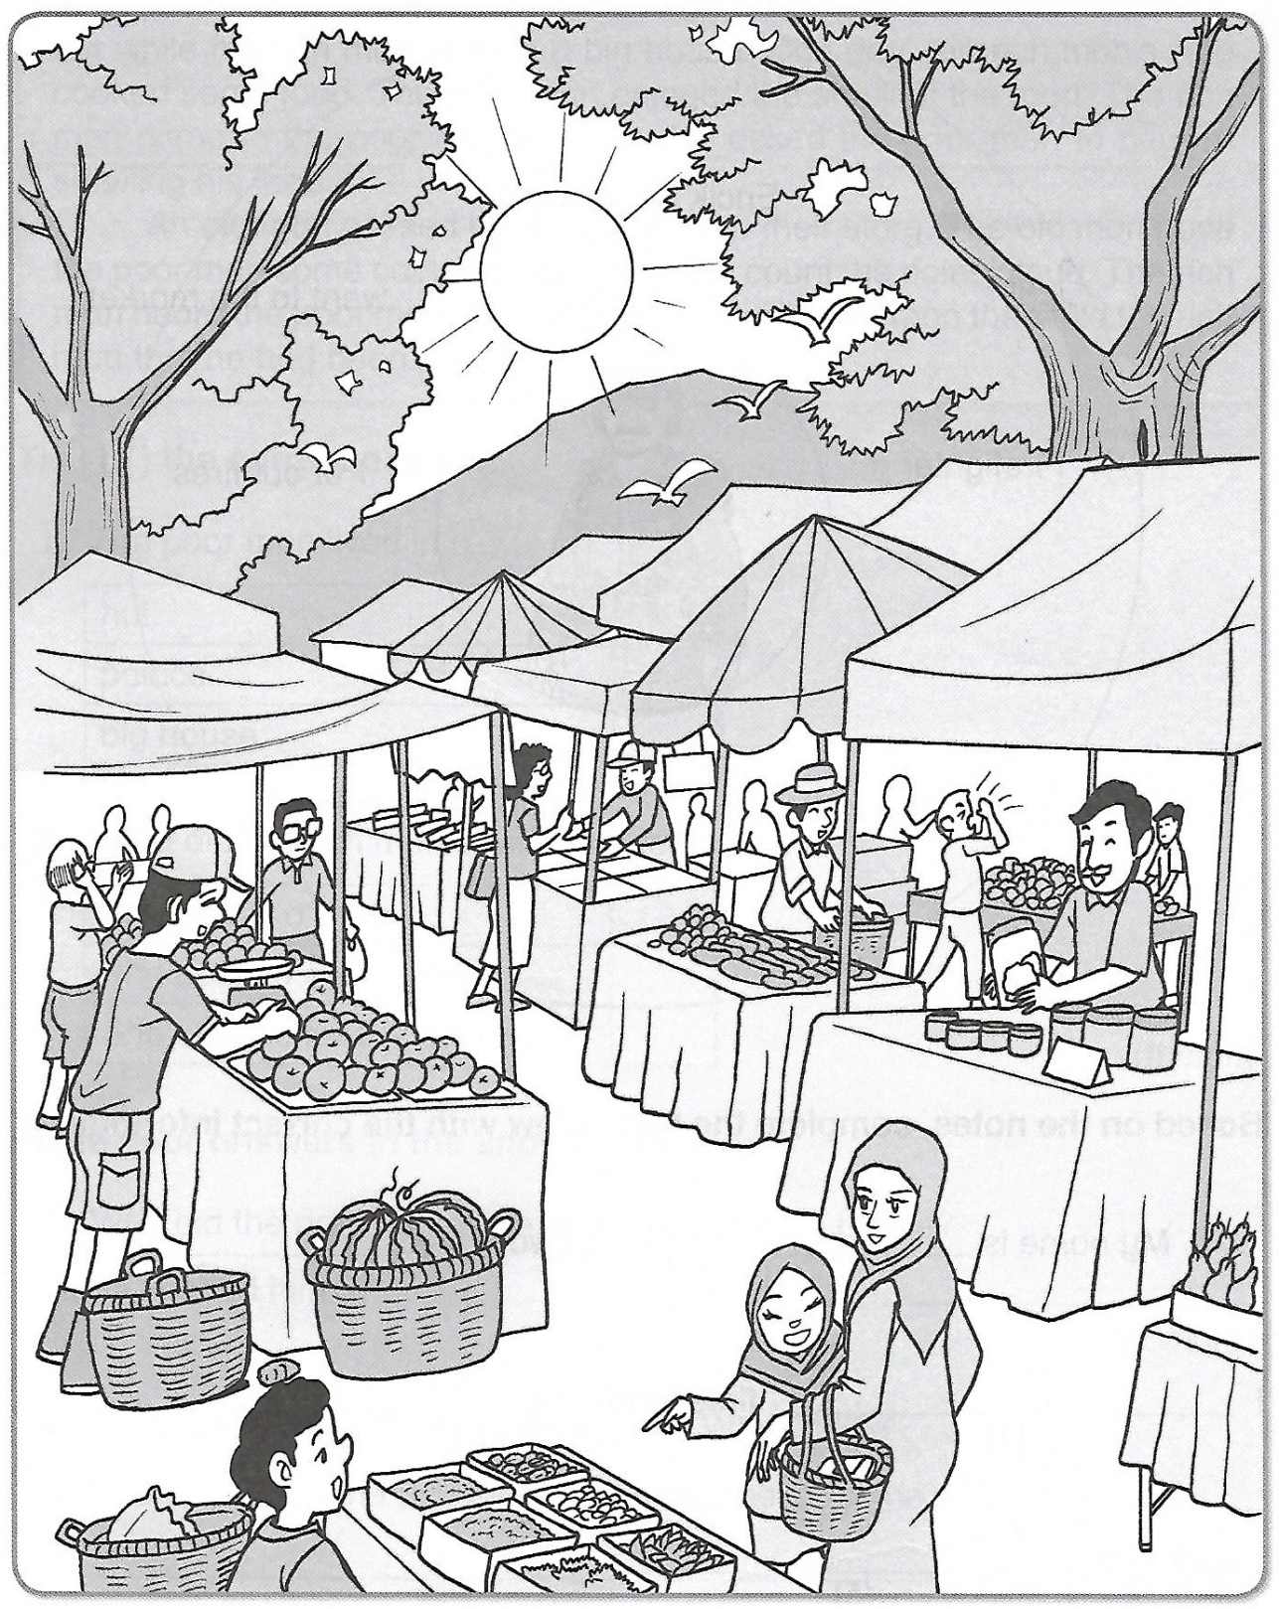

Begin your story with:

Last Sunday, my mother and I …….
1.
selling different things.
went to the market.
at 10 a.m.
at the fruit stall.
Last Sunday, my mother and I

I saw many stalls
2.

3.
We bought some fruits

We went home
4.

_________________________________________________________________________________________________________________________________________________________________________________________________________________________________________________________________________________________________________________________________________________________________________________________________________________________________________________________________________________________________________________________________________________________________________________________________________________________________________________________________________________________________________________________________________________________________________________________________________________________________________________
End of question
ANSWER SCHEME
Section A
- Encik Shamsuddin
- firefighter
- put out
- flood victims
- fire station

Section B(i)

- Turn off the tap
- Use a watering can
- Use the shower

Section B(ii)

- reduce the use of plastic bags
- to take care of the beach
- throw rubbish into the sea
- release toxic wastes

Section C

Question 1

- wash and cut the strawberries
- put the strawberries
- some ice cubes
- all the ingredients until smooth
- pour the smoothie into a glass

Question 2

Last Sunday, my mother and I
I saw many stalls
We bought some fruits
We went home
at the fruit stall.
at 10 a.m.
went to the market.
selling different things.

Last Sunday, my mother and I went to the market. I saw many stalls selling different things. We bought some fruits at the fruit stall. We went home at 10 a.m.

