SULIT

BAHASA INGGERIS
Kertas 2 - Penulisan
Tahun 6
Mei
2017
1$\frac{1}{4}$ jam

PEPERIKSAAN PERTENGAHAN TAHUN 2017
TAHUN 6

Nama : …………………………………………………………………………. Kelas : ………………………………………………..

BAHASA INGGERIS
Kertas 2 - Penulisan

Satu Jam lima belas minit

JANGAN BUKA KERTAS SOALAN SEHINGGA DIBERITAHU

- Kertas soalan ini mengandungi tiga bahagian : Bahagian A, Bahagian B dan Bahagian C.
- Kamu dikehendaki menjawab ketiga-tiga bahagian.
- Bagi Bahagian C, kamu boleh memilih sama ada menjawab Soalan 1 atau Soalan 2.
- Jawapan kamu hendaklah ditulis pada ruang yang disediakan dalam kertas soalan ini.

Kertas soalan ini mengandungi 9 halaman bercetak

SECTION A
[10 marks]

Study the information on the book cover below and use the information to complete the text.

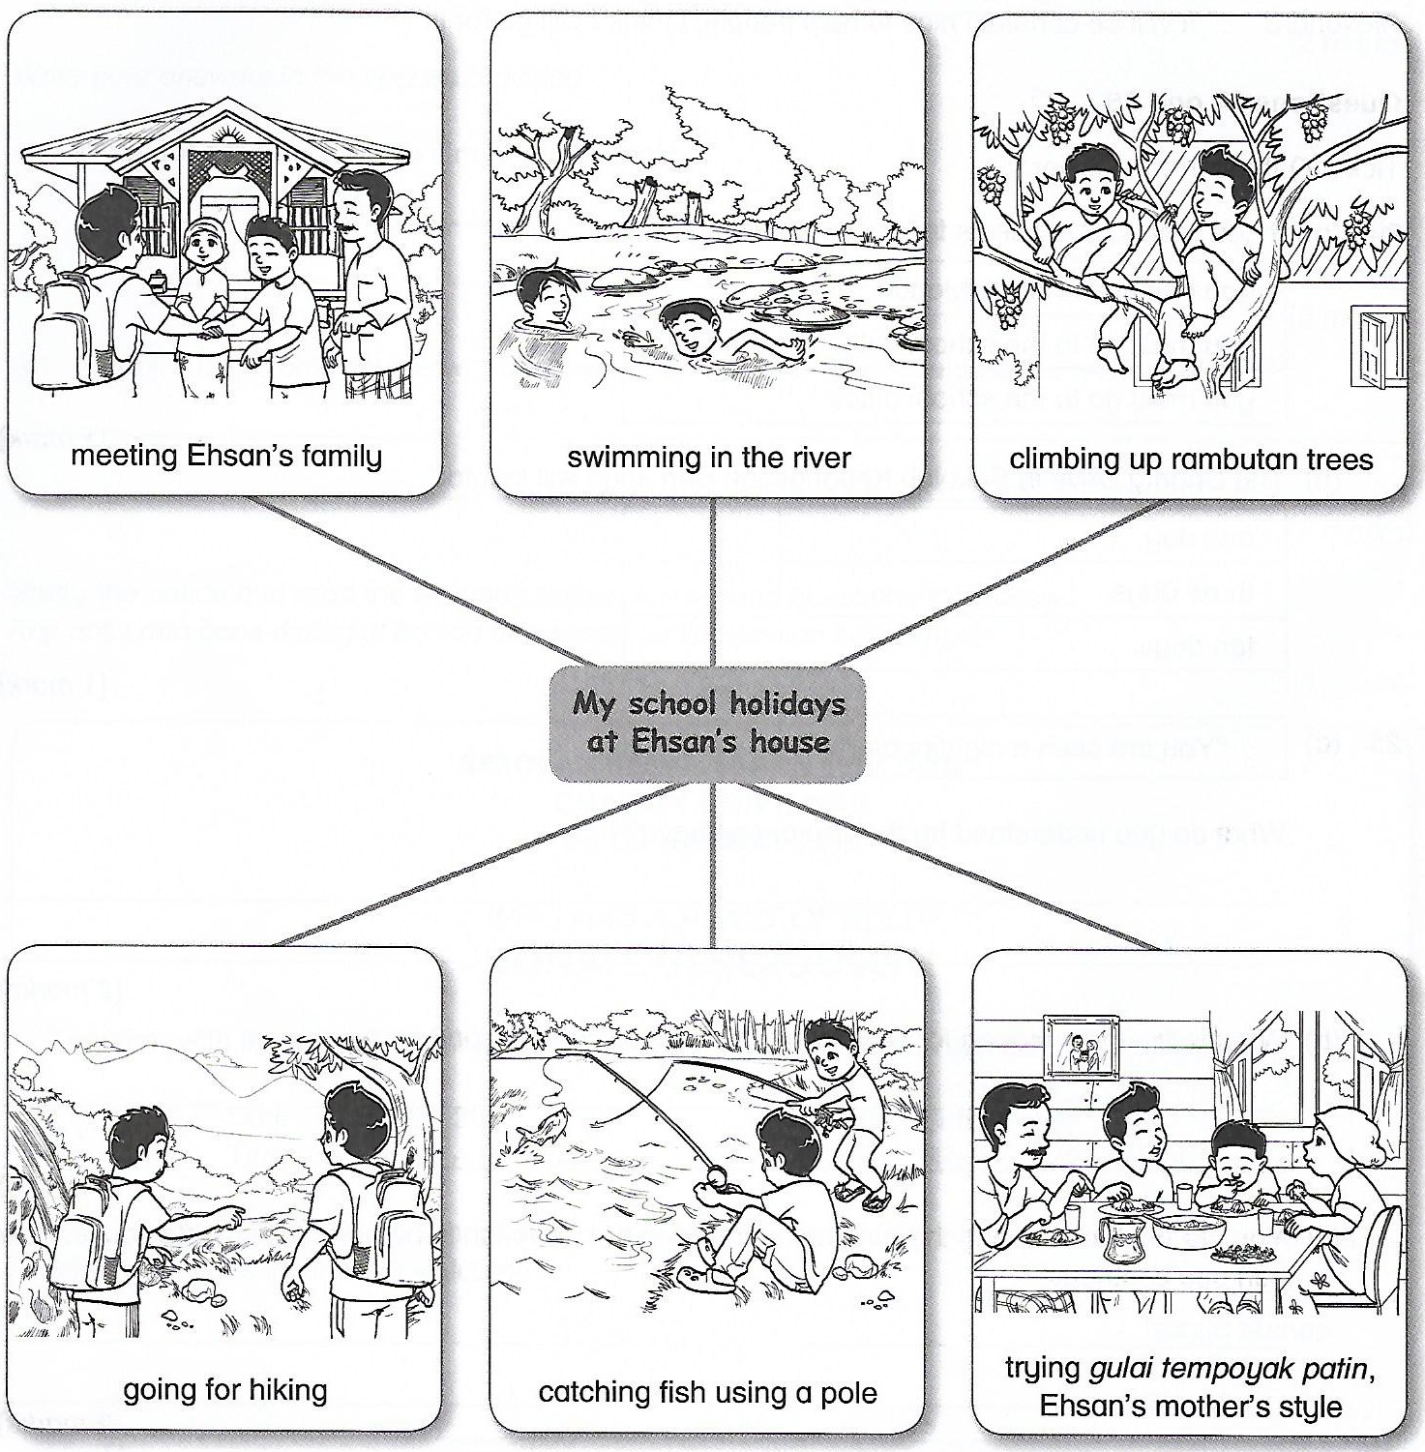

Based on the mind map, complete the text below with the correct information.
From : roy.nizam@gmail.com | Date: 19 September 2016
To: boy.ehsan@gmail.com | Time: 9:00 p.m.
Subject: Thank you
Dear Ehsan Yusfikri,

I would like to thank you for having me at your house during recent school holidays. It was a great pleasure to meet (1) _________________________________________. I was very pleased as I was given a warm welcome.
I had a lot of fun there. It was my first time going (2) _________________________________________. The water was crystal clear. Thanks for teaching me how to swim. On that evening, we (3) _________________________________________ the rambutan tree. I still remember the ants’ bites. Yeah, it was hurt.
The next day, we went for hiking the hill. I was happy because we (4) _________________________________________ for lunch. It was a meaningful experience to me. The view from the top of the hill was breathtaking.
Last but not least, your (5) _________________________________________ was finger-licking good. I still remember the taste of the gulai tempoyak patin.
I really hope you can visit me on the next school holiday. I will show you how to make a wau bulan
when you come here. Hope to meet you soon.

Nizam

SECTION B
[15 marks]

B(i)

Study the notice about environmental awareness campaign and answer the following question in the spaces provided.

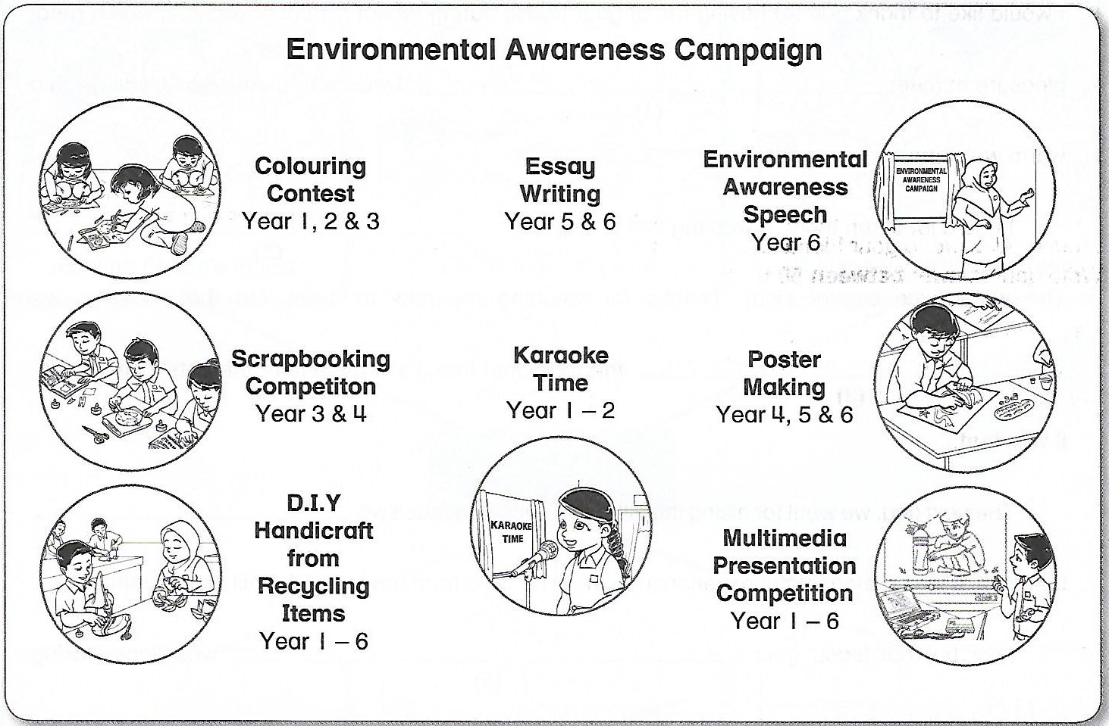

List three activities that your ten-year-old brother can join during the campaign at school.

i. _______________________________________________________________________

ii. _______________________________________________________________________

iii. _______________________________________________________________________

[3 marks]

B(ii)

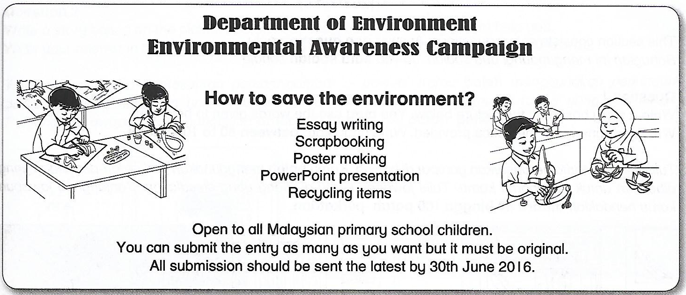
You have read an advertisement in a magazine about the environmental awareness campaign.
Write a postcard to your friend suggest him/her a few competitions that they can join.
Write your answer between 50 to 80 words.

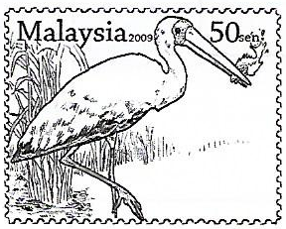

[12 marks]
SECTION C
[25 marks]

This section consists of two questions. Answer one question only.

Question 1

Write a story based on the picture below. You may use the words given to help you.
Write your answer in the space provided. Write your story between 80 to 100 words.

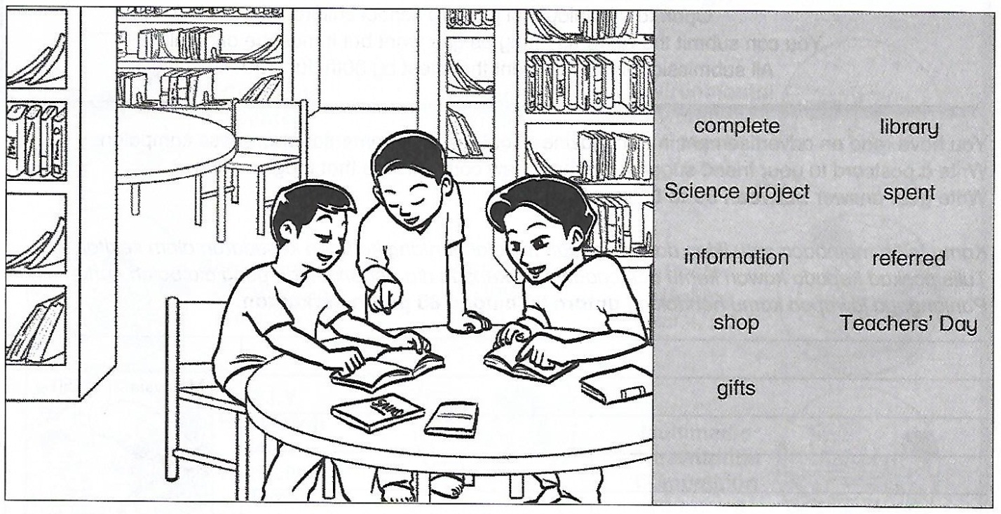
vfv
Begin your story with:
Zali and his friends were given a task by their teacher. They needed….

OR
Question 2

Write a story based on the pictures below. You may use the words given to help you.
Write your answer in the space provided. Write your description between 80 to 100 words.

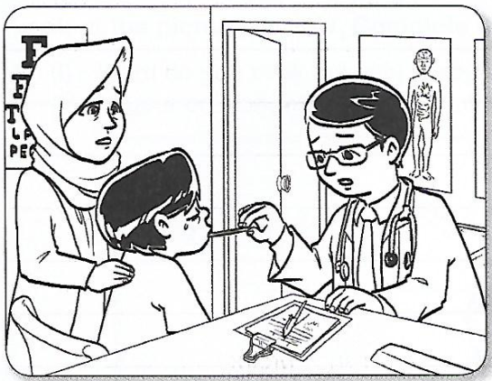

- feverish - aching - doctor - dengue - warded

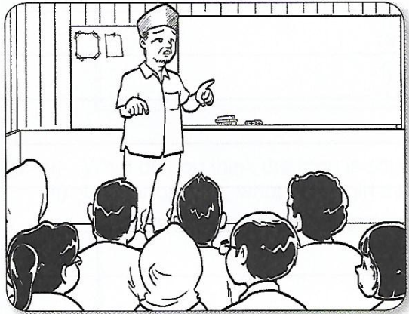

- informed - headman - emergency - around - breeding

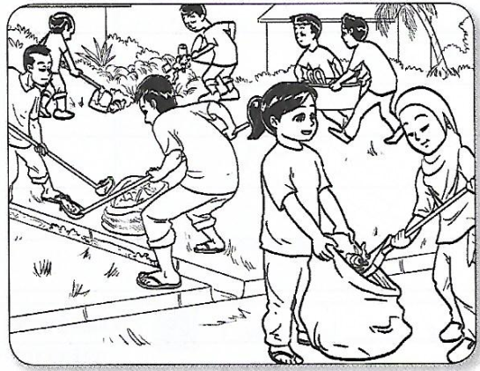
- ‘gotong-royong’ - buried - empty - mosquitoes’

Question :

_______________________________________________________________________________________________________________________________________________________________________________________________________________________________________________________________________________________________________________________________________________
_______________________________________________________________________________________________________________________________________________________________________________________________________________________________________________________________________________________________________________________________________________
_______________________________________________________________________________________________________________________________________________________________________________________________________________________________________________________________________________________________________________________________________________
_______________________________________________________________________________________________________________________________________________________________________________________________________________________________________________________________________________________________________________________________________________
_______________________________________________________________________________________________________________________________________________________________________________________________________________________________________________________________________________________________________________________________________________
__________________________________________________________________________________________________________________________________________________________________________

_______________________________________________________________________________________________________________________________________________________________________________________________________________________________________________________________________________________________________________________________________________
_______________________________________________________________________________________________________________________________________________________________________________________________________________________________________________________________________________________________________________________________________________
_______________________________________________________________________________________________________________________________________________________________________________________________________________________________________________________________________________________________________________________________________________
_______________________________________________________________________________________________________________________________________________________________________________________________________________________________________________________________________________________________________________________________________________
_______________________________________________________________________________________________________________________________________________________________________________________________________________________________________________________________________________________________________________________________________________
__________________________________________________________________________________________________________________________________________________________________________

End of question
ANSWER SCHEME

Section A

- you and your family
- to the river
- climbed up
- caught our own fish
- mother’s cooking

Section B

B(i)

- poster making
- scrapbooking competition
- multimedia presentation competition

B(ii)

Dear Natasya,  I found this advertisement on Environmental Awareness Campaign. There are some competition that I think you would like to join. Personally, I believe you can make a scrapbook on how to save the environment. I love your previous scrapbook about our Independence Day. You can also make a poster. I know you are good at drawing. Or, you can produce a multimedia presentation using Microsoft PowerPoint. Hurry up and buy the magazine and don’t forget the closing date is 30th june 2016.  Your friend,  Marina | To:  Natasya binti Sazali,  No.13 Jalan 1/3,  Taman Bukit Cermin,  28400 Mentakab,  Pahang.

Section C

Question 1

Zali and his friends were given a task by their teacher. They needed to complete it within a week. They boys decided to go to the library to get information for their Science project.
The boys spent a few hours there to gather the information. They copied down whatever information that was useful and relevant. They referred to many sources.
After that, the boys went to the mall nearby to shop for Teacher’s Day gifts for their beloved teachers. They went to a few shops to look for their choice. After getting what they needed, the boys went home exhausted but elated.

Question 2

Last Saturday, when Azman woke up in the morning, he felt feverish and his body was aching. His mother, Puan Azimah, took him to the hospital near their house. The doctor examine Azman and comfirmed that he was having dengue fever. He was warded immediately.
His mother informed the headman. The next day, the headman had an emergency meeting with the villagers. They went around the village and discovered many mosquitoes’ breeding places.
They decided to have a ‘gotong-royong’. They cleared the dumping ground and buried all the empty containers. They helped to get rid of the mosquitoes’ breeding places.

